**Infrastructure and Institution**

The Institution follows a policy of creating new infrastructure or enhancing the exciting infrastructure to fulfill the requirements of AICTE.However the institution has a structured mechanism for the creation and enhancement of additional infrastructure beyond the statutory requirements to facilitate effective teaching -learning.

**ADVANCE TRAINING RESTAURANT**

**(Practical Lab)**

ATR is the advanced training restaurant which has everything to do with the commencement of the practical knowledge with advanced equipment, furniture and bar.

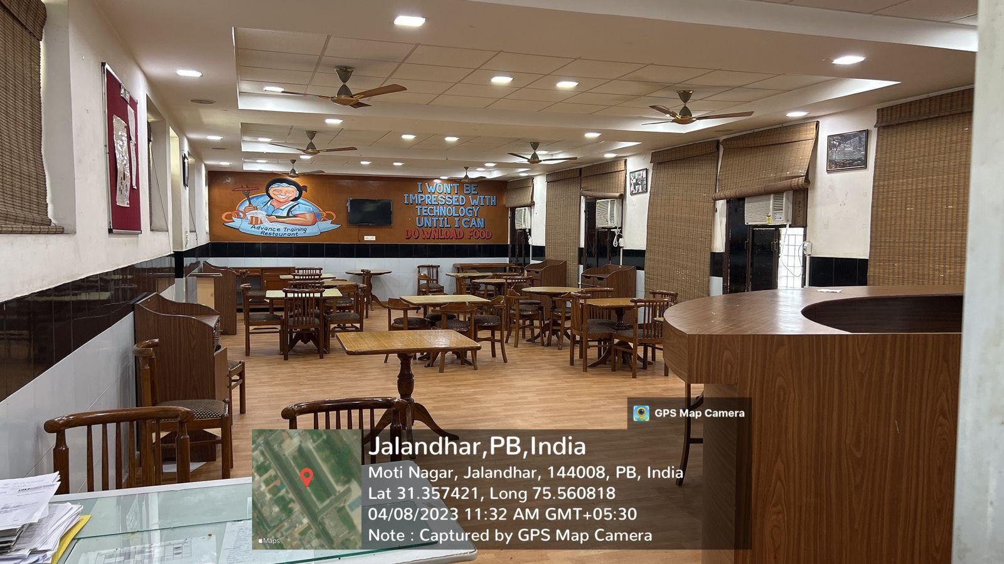

**BASIC TRAINING RESTAURANT**

BTR is the advanced training restaurant which has everything to do with the commencement of the practical knowledge with all the equipment, furniture and bar.

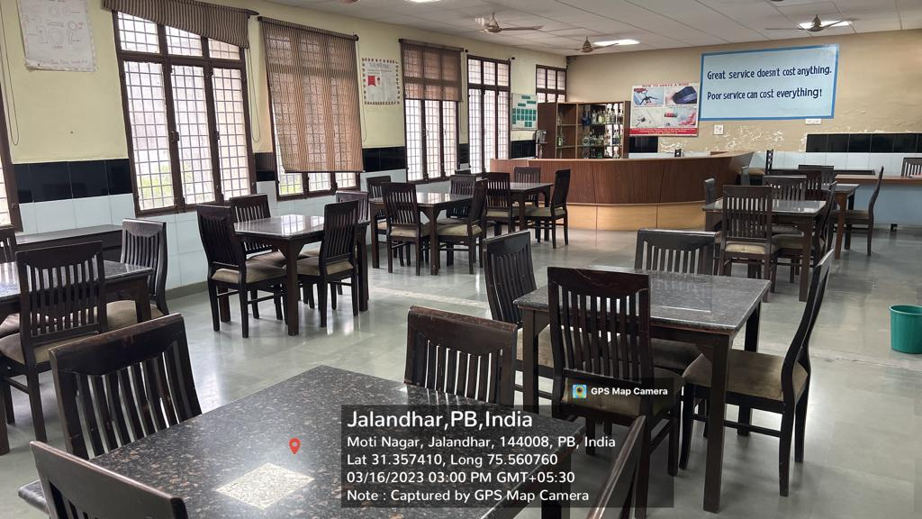

**CT AIRWAYS LAB**

A beautiful real time airplane which is the best to give our students the experience of aviation.

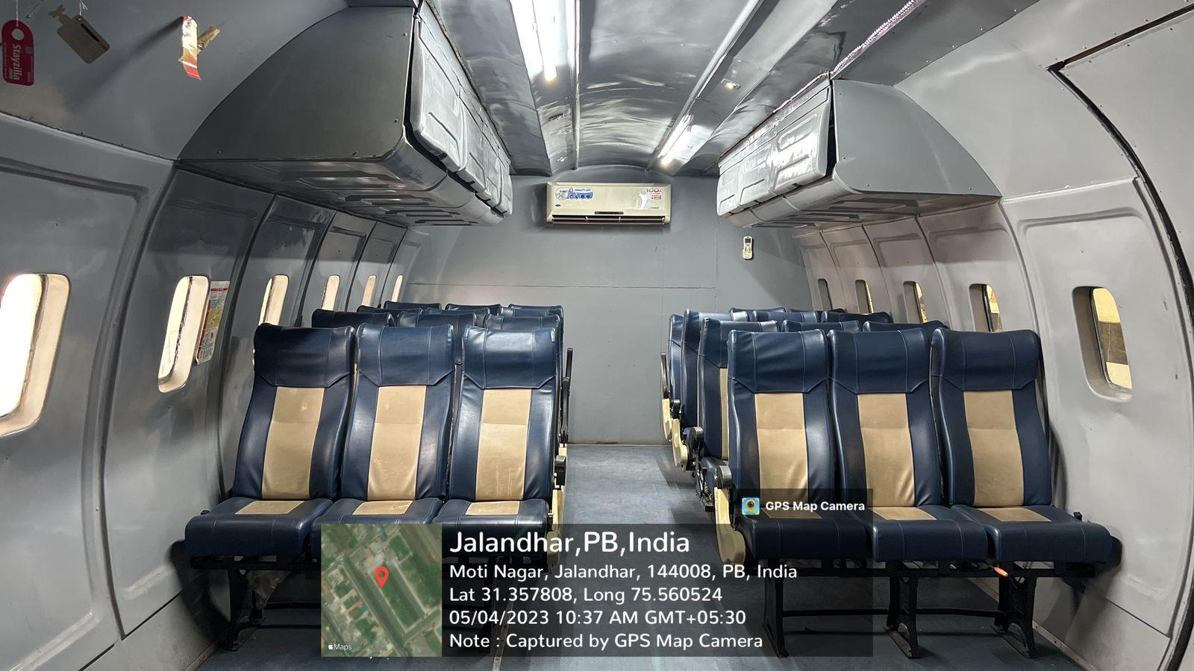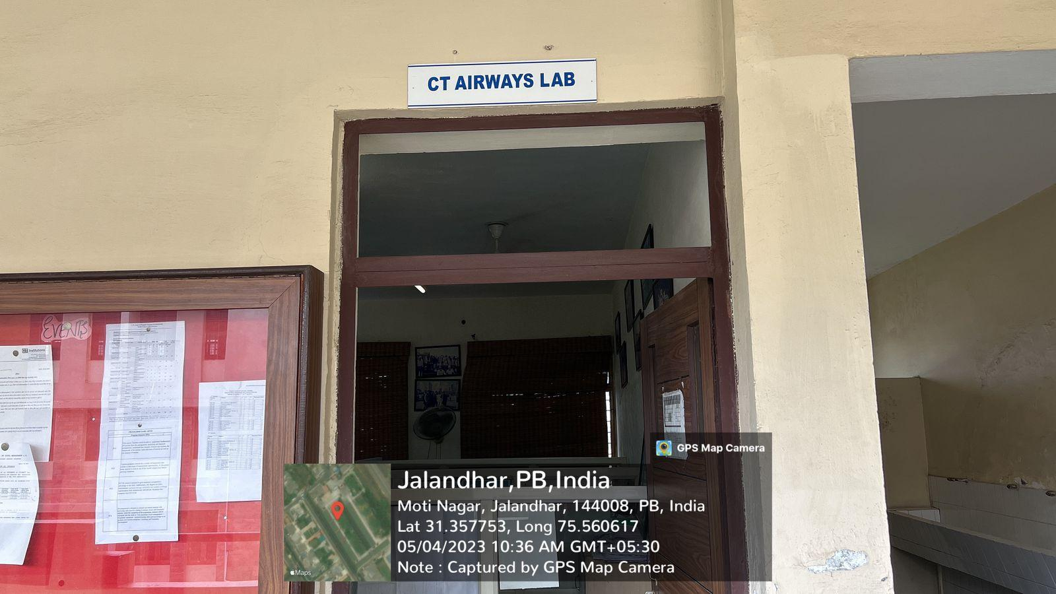

**BASIC TRAINING KITCHEN (BTK)\**

BTK is the Basic Training Kitchen for the students at CT where they can perform their basic practical related to food production.

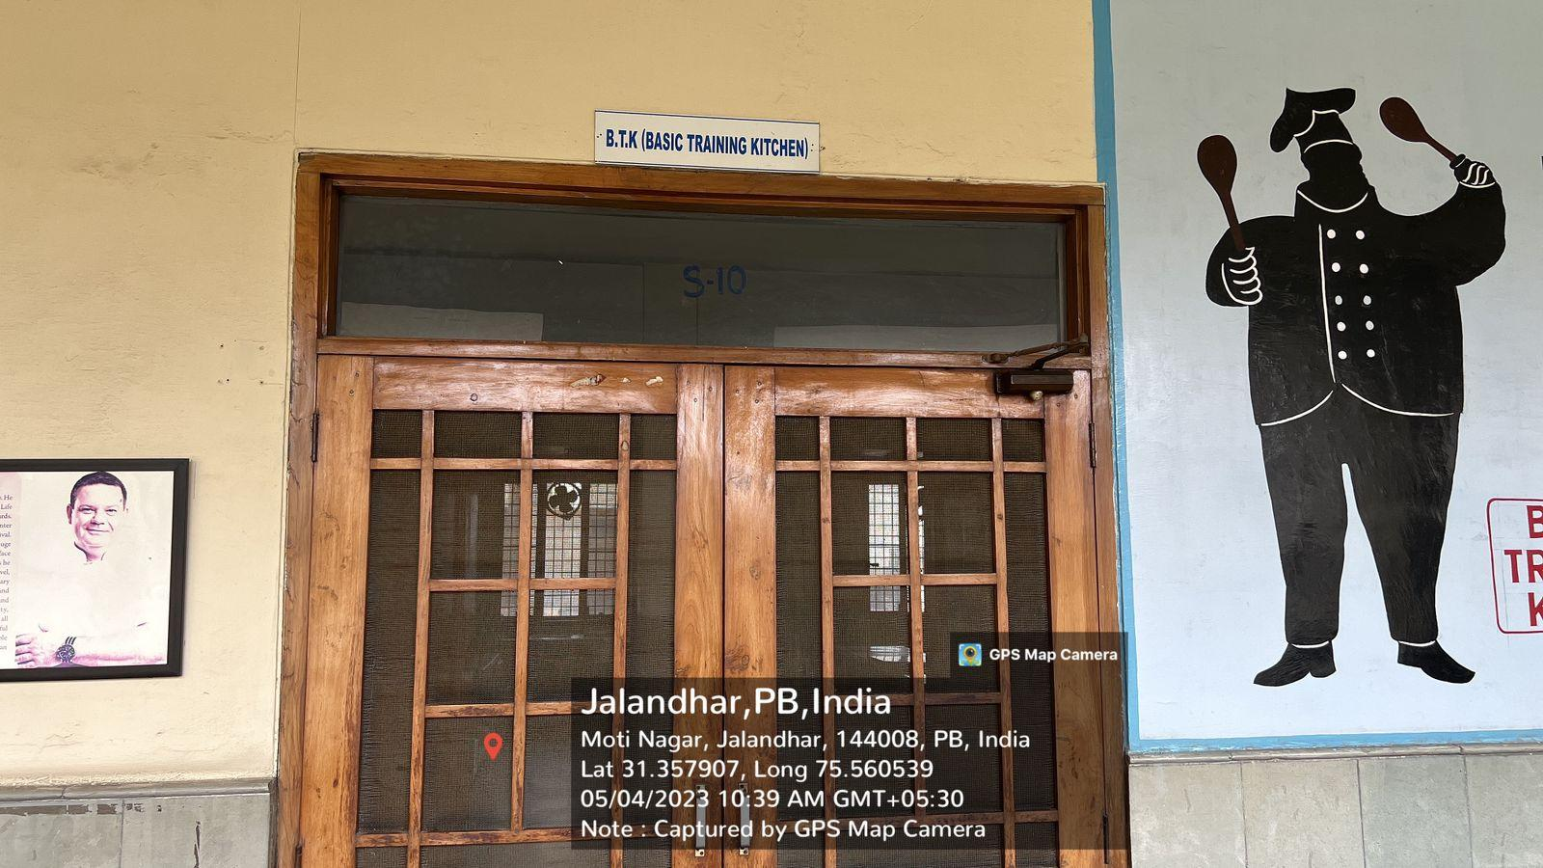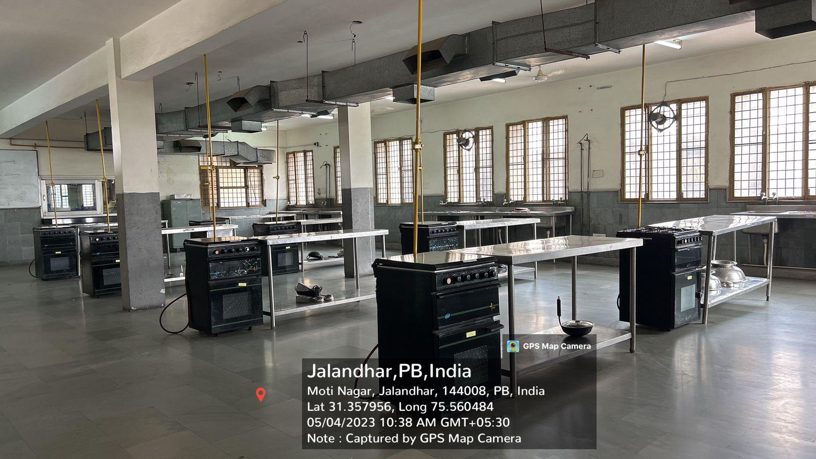

**QUANTITY TRAINING KITCHEN (QTK)**

QTK is the Quantity Training Kitchen for the students at CT where they can perform their practical related to food production.

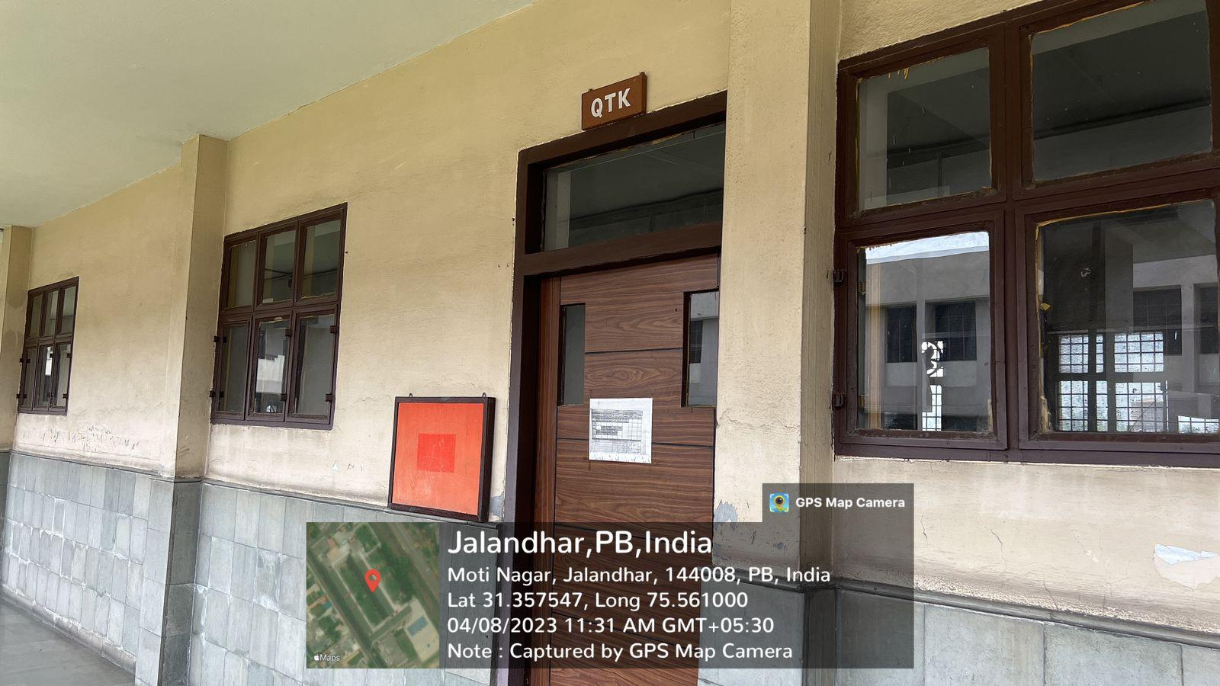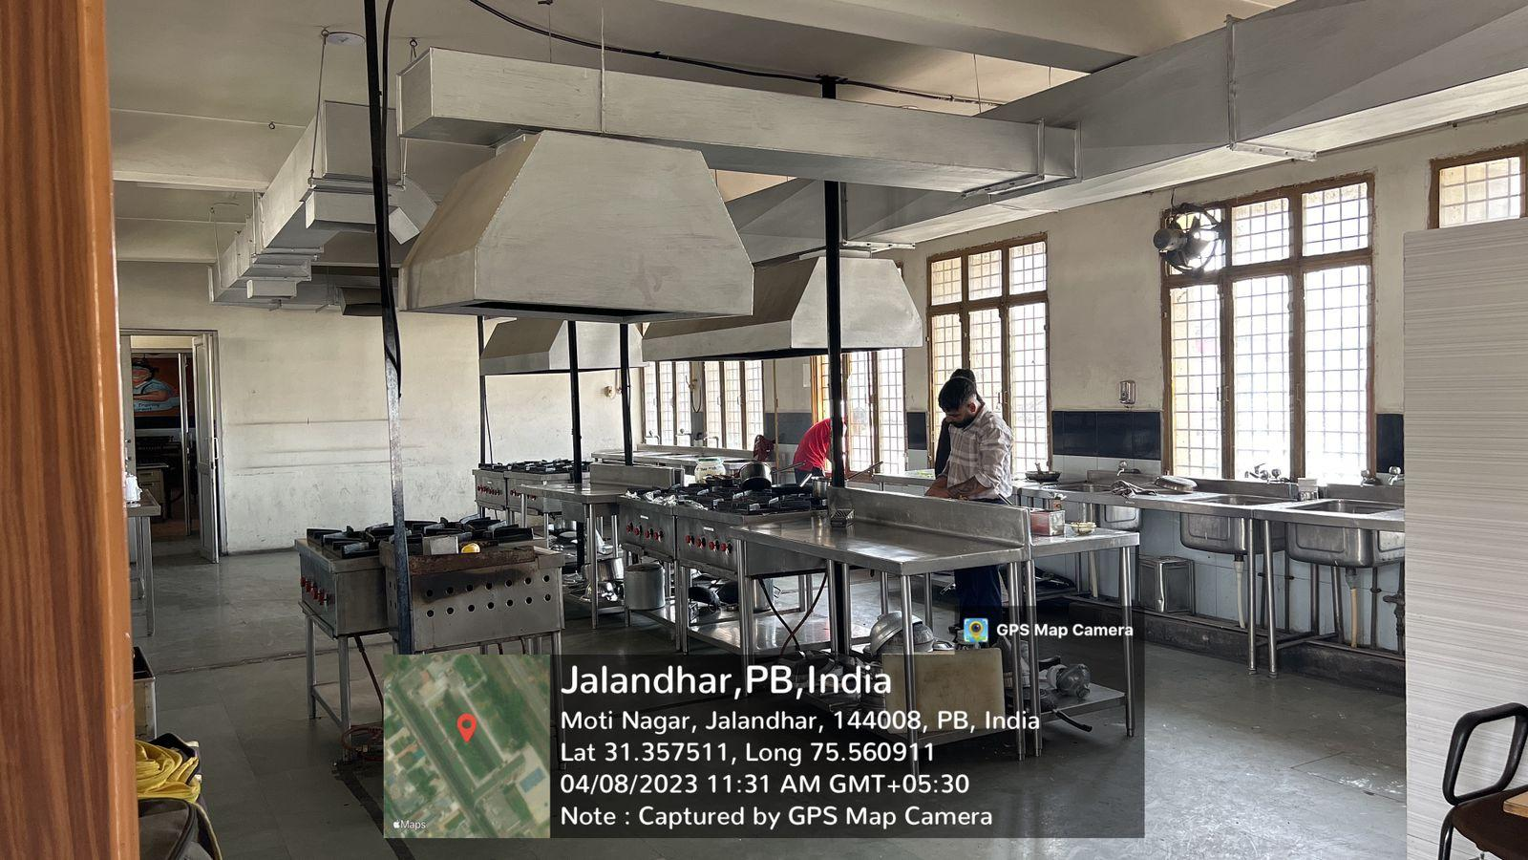

**ADVANCE TRAINING KITCHEN (ATK)**

ATK is the Advanced Training Kitchen for the students at CT where they can perform their practical related to food production.

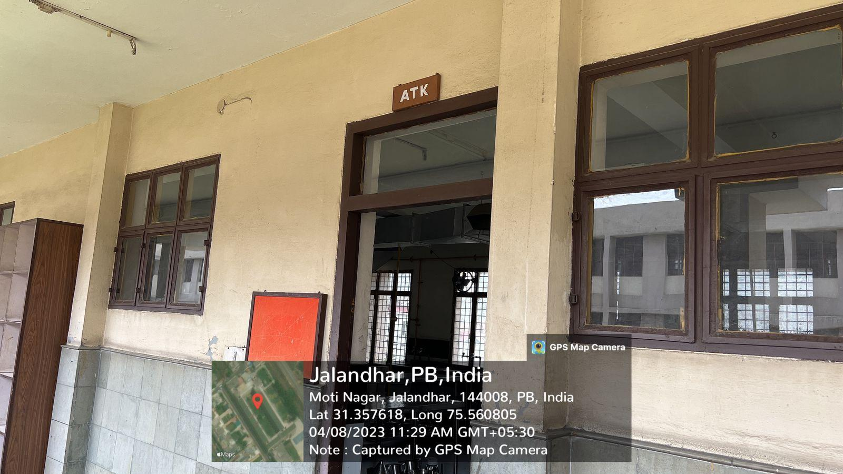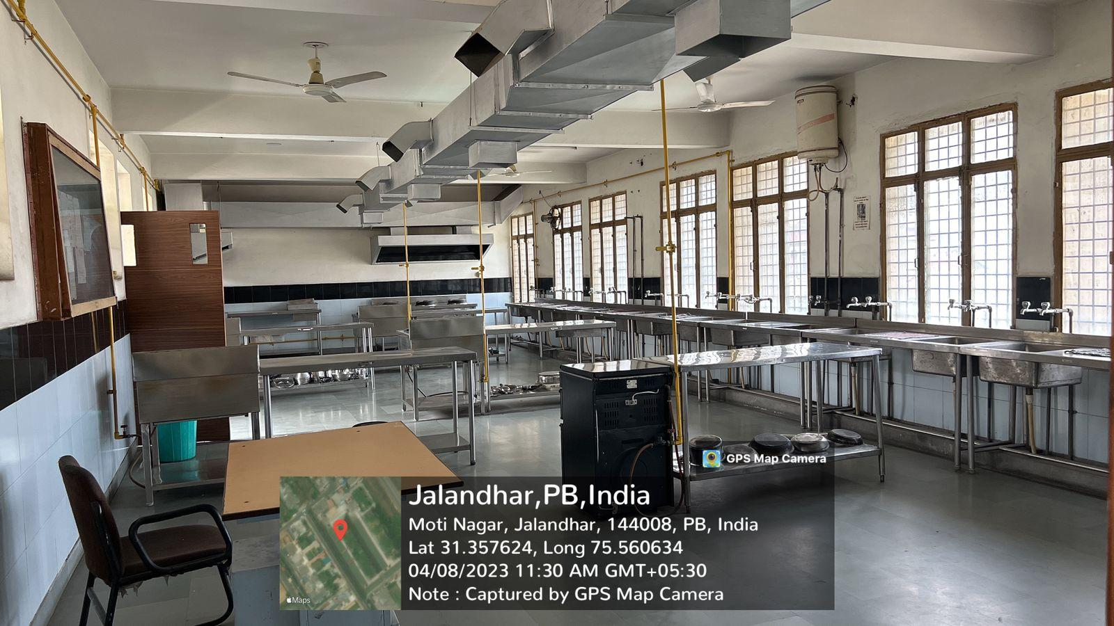

**DEMONSTRATION KITCHEN**

Demonstration Kitchen for the students at CT where they can perform their practical related to food production.

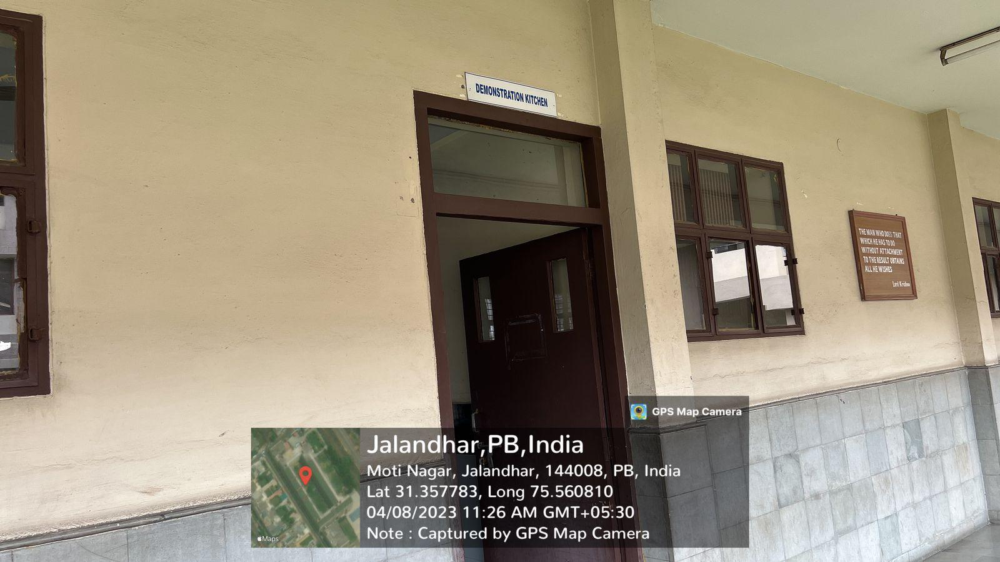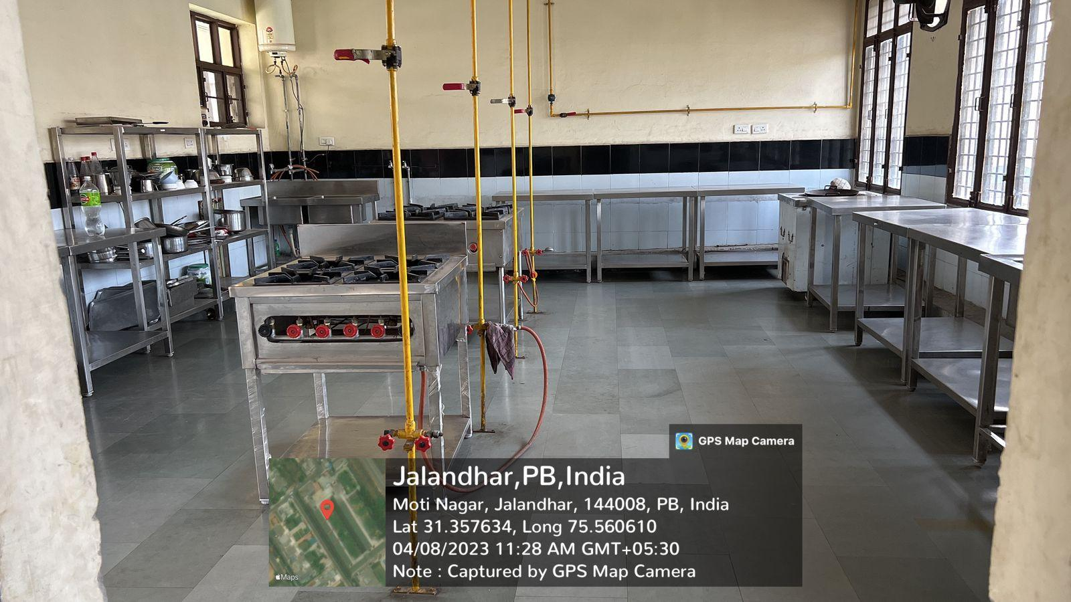

**MODEL GUEST ROOM**

Model Guest Room is a room where all the practical related to Housekeeping are performed.

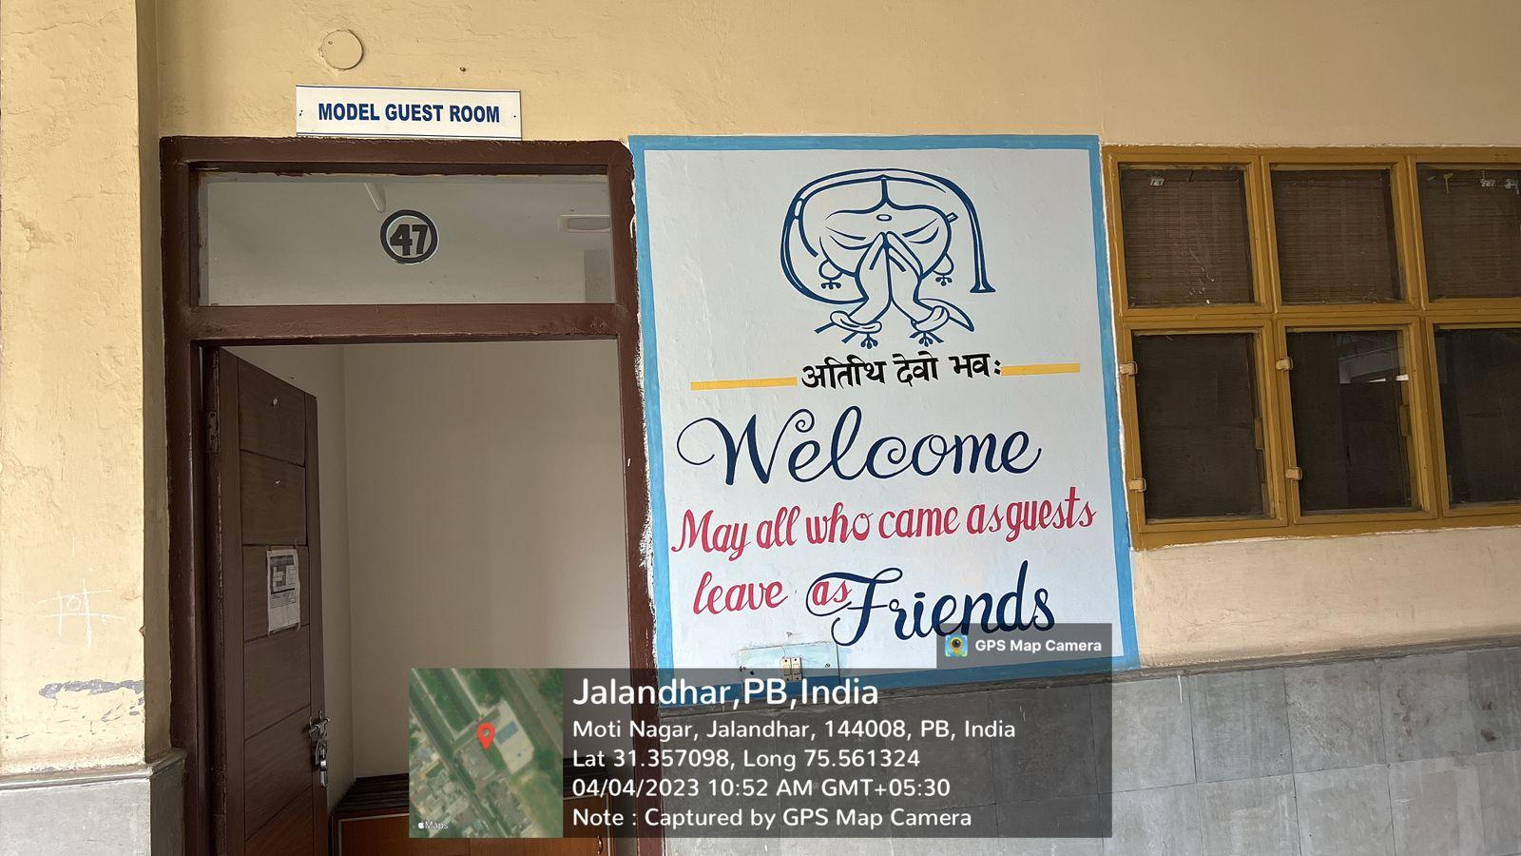

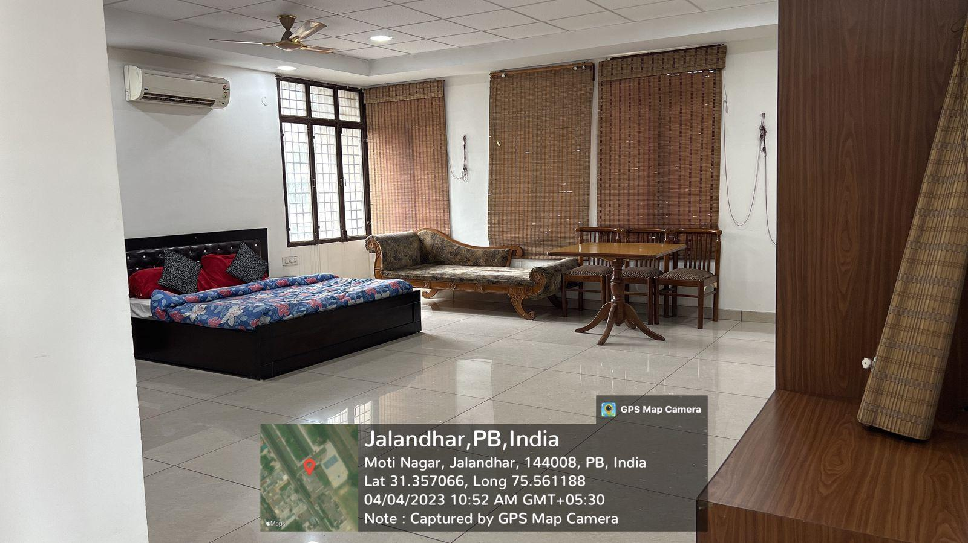

**BAKERY**

Bakery nade for the students at CT where they can perform their bakery practical.

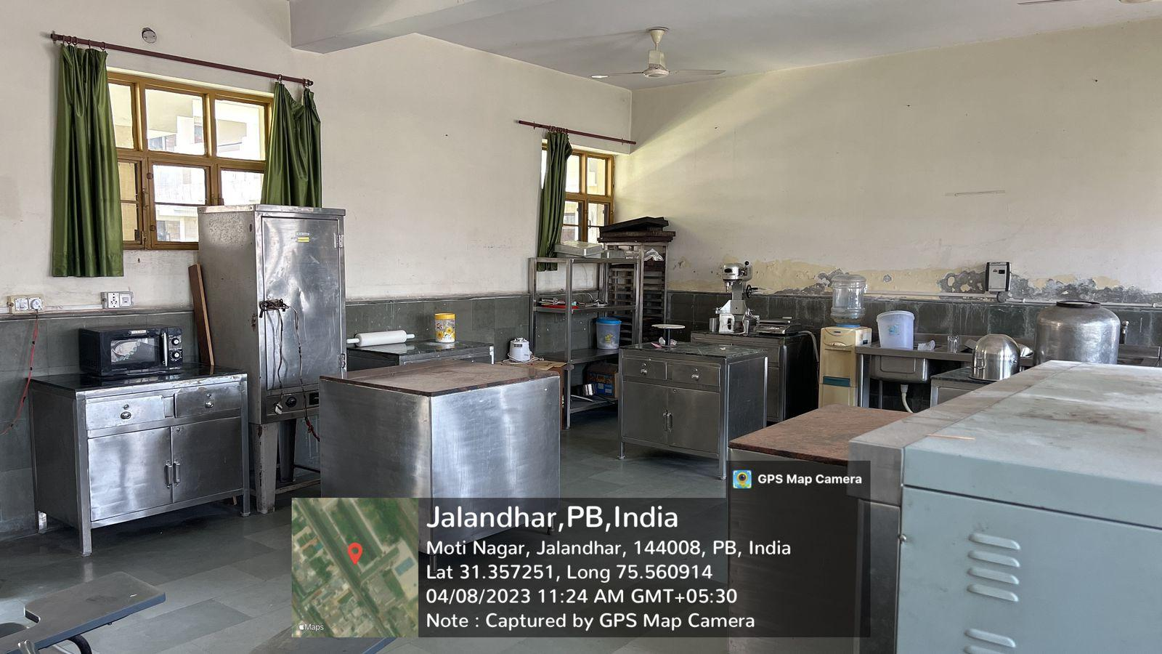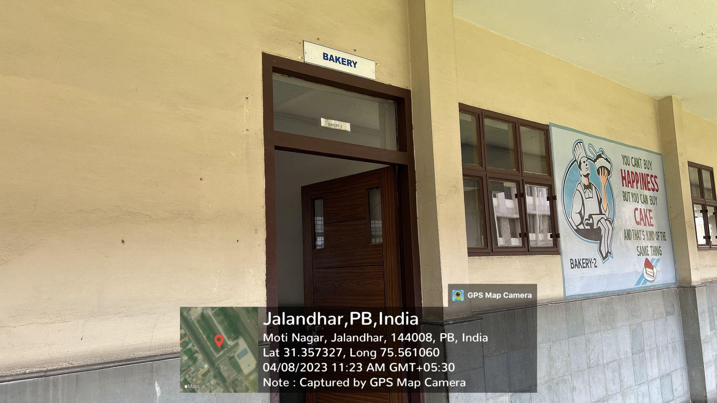

**HOUSEKEEPING LAB**

Housekeeping Lab for the students at CT where they can perform their housekeeping practical.

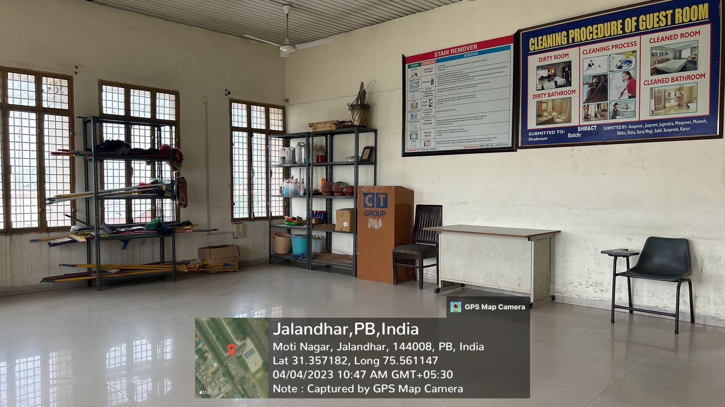

**FRONT OFFICE LAB**

Front Office Lab for the students at CT where they can perform their basic practical related to front office.

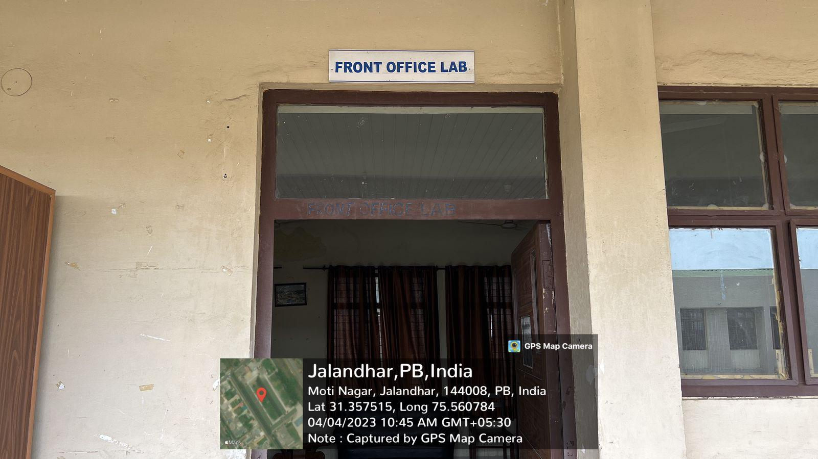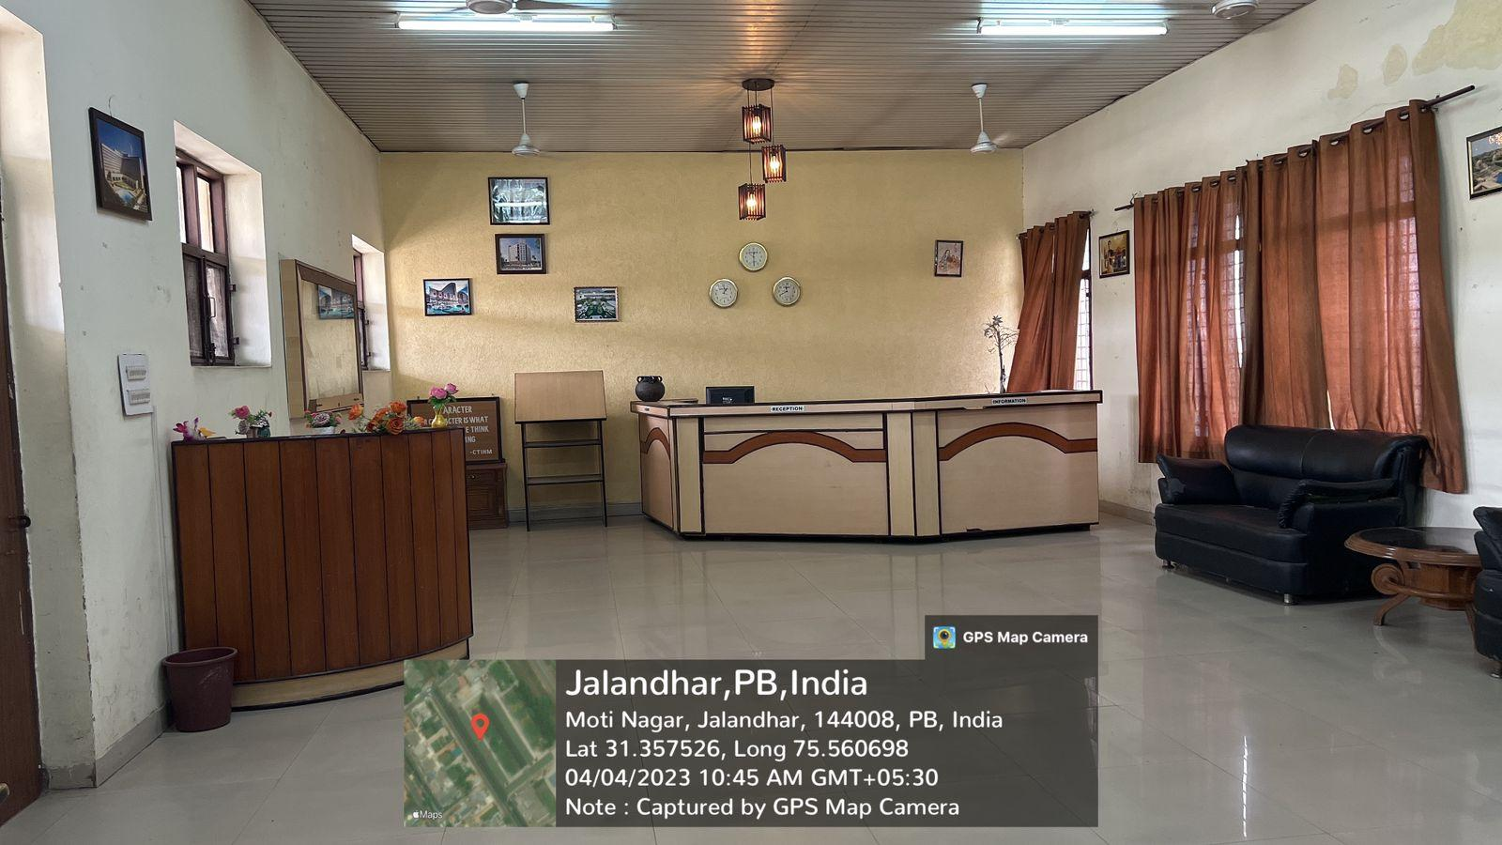

**HOD OFFICE**

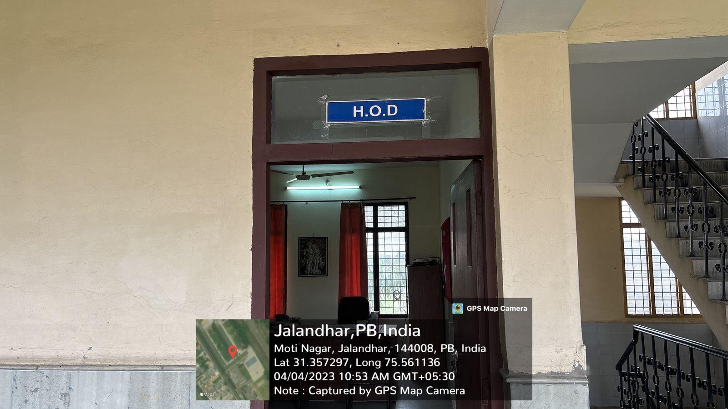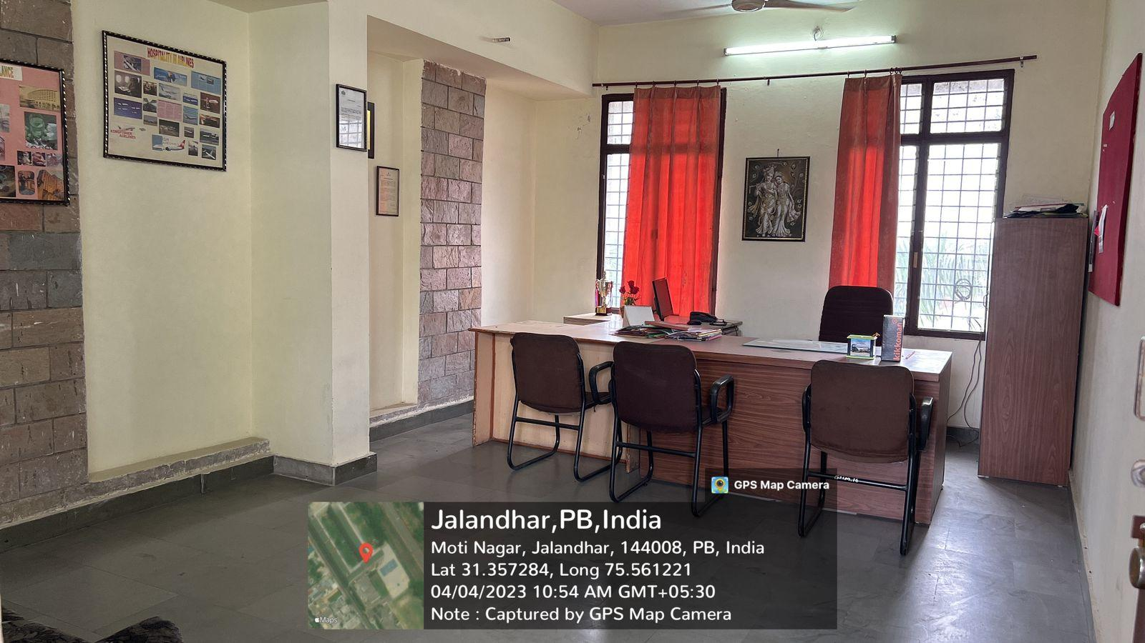

**MEDIA STUDIOLAB**

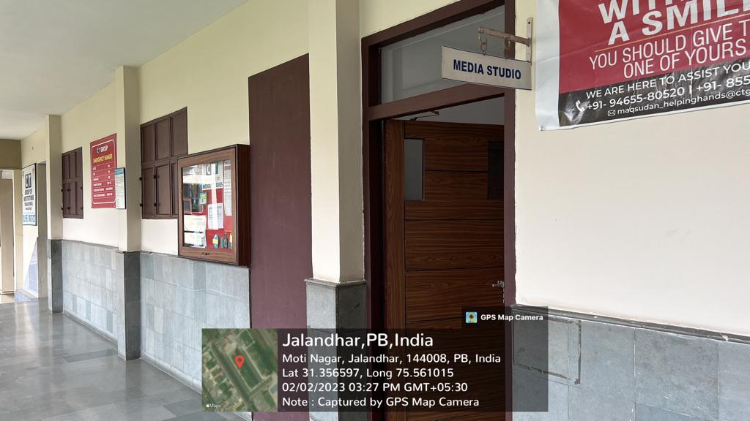

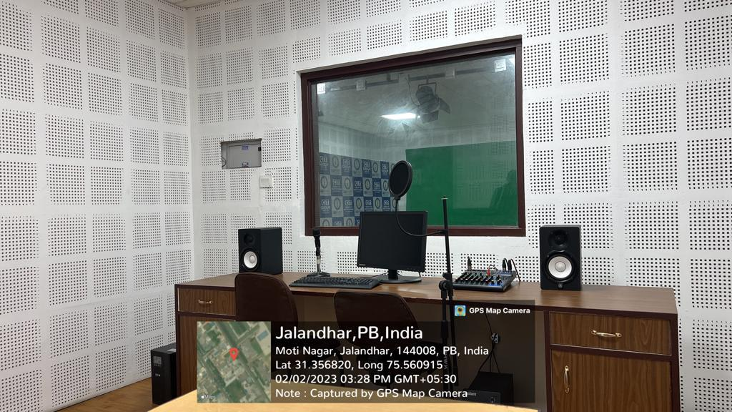

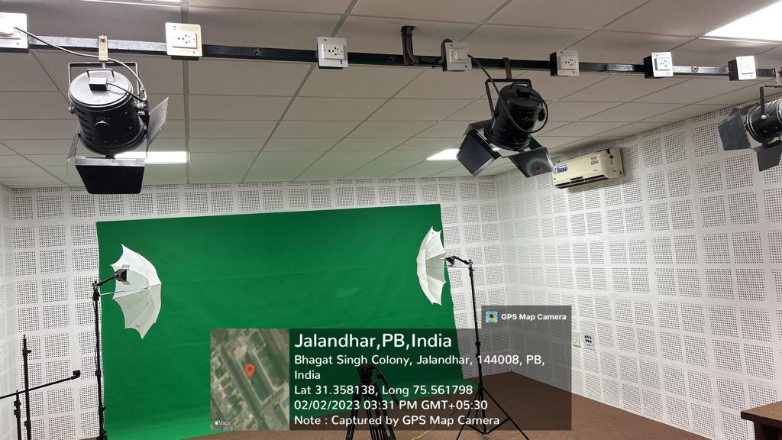

**ANIMATION & DRAWING LAB**

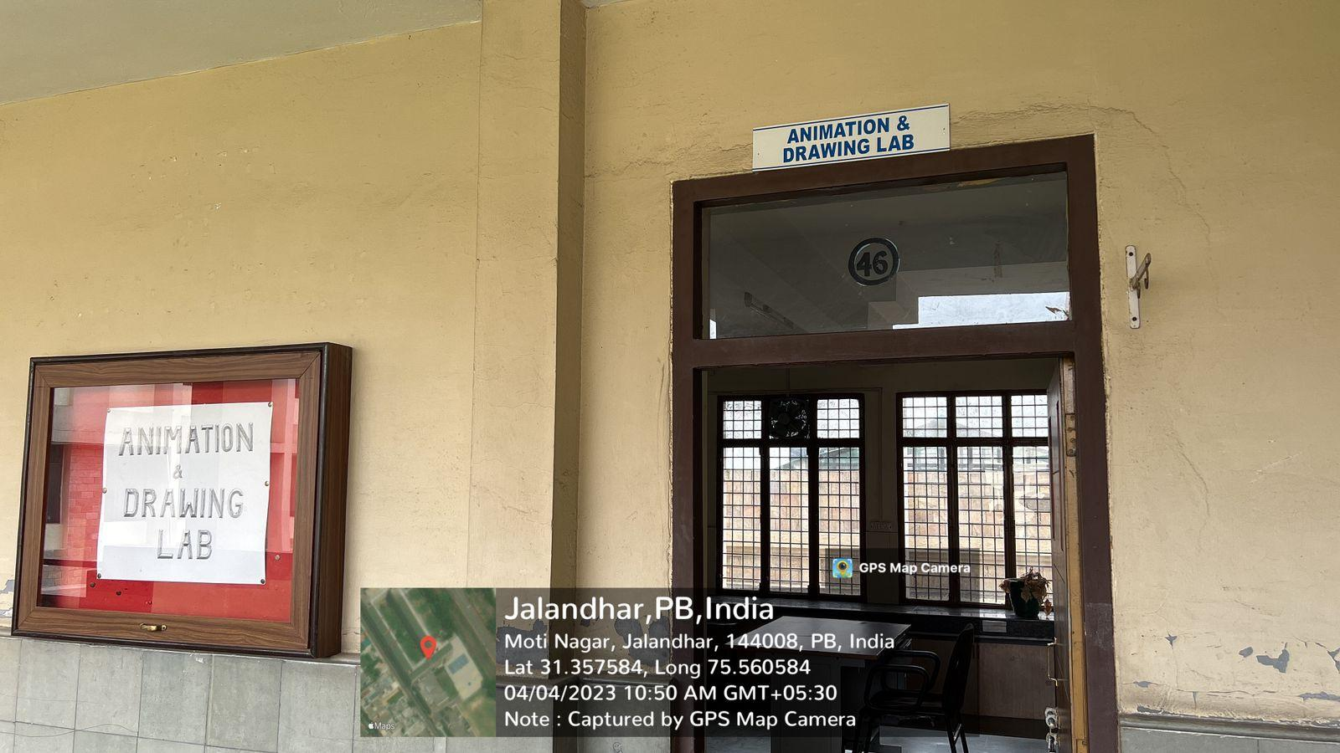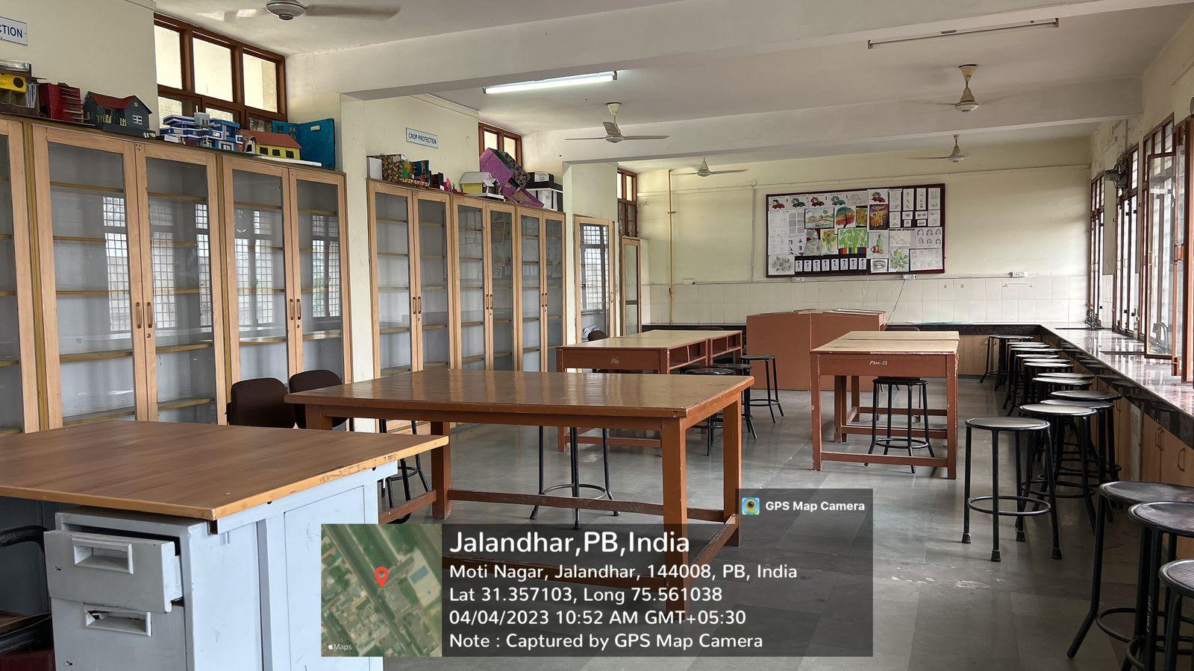

**NETWORKING LAB**

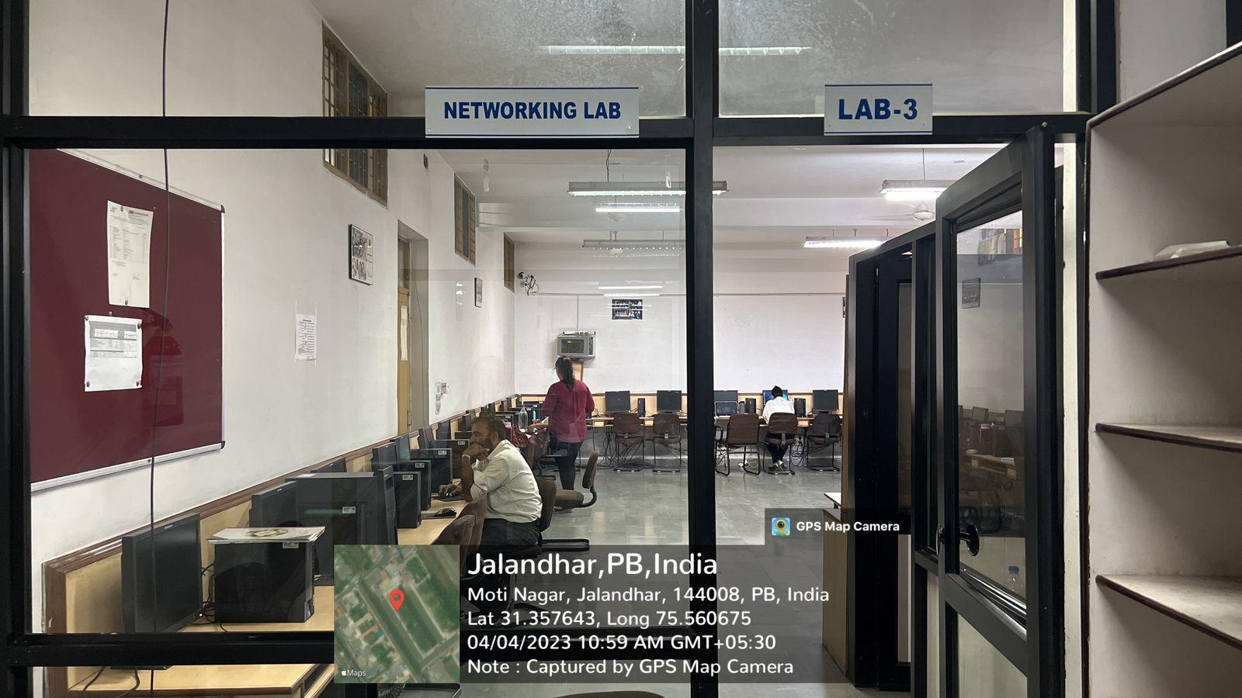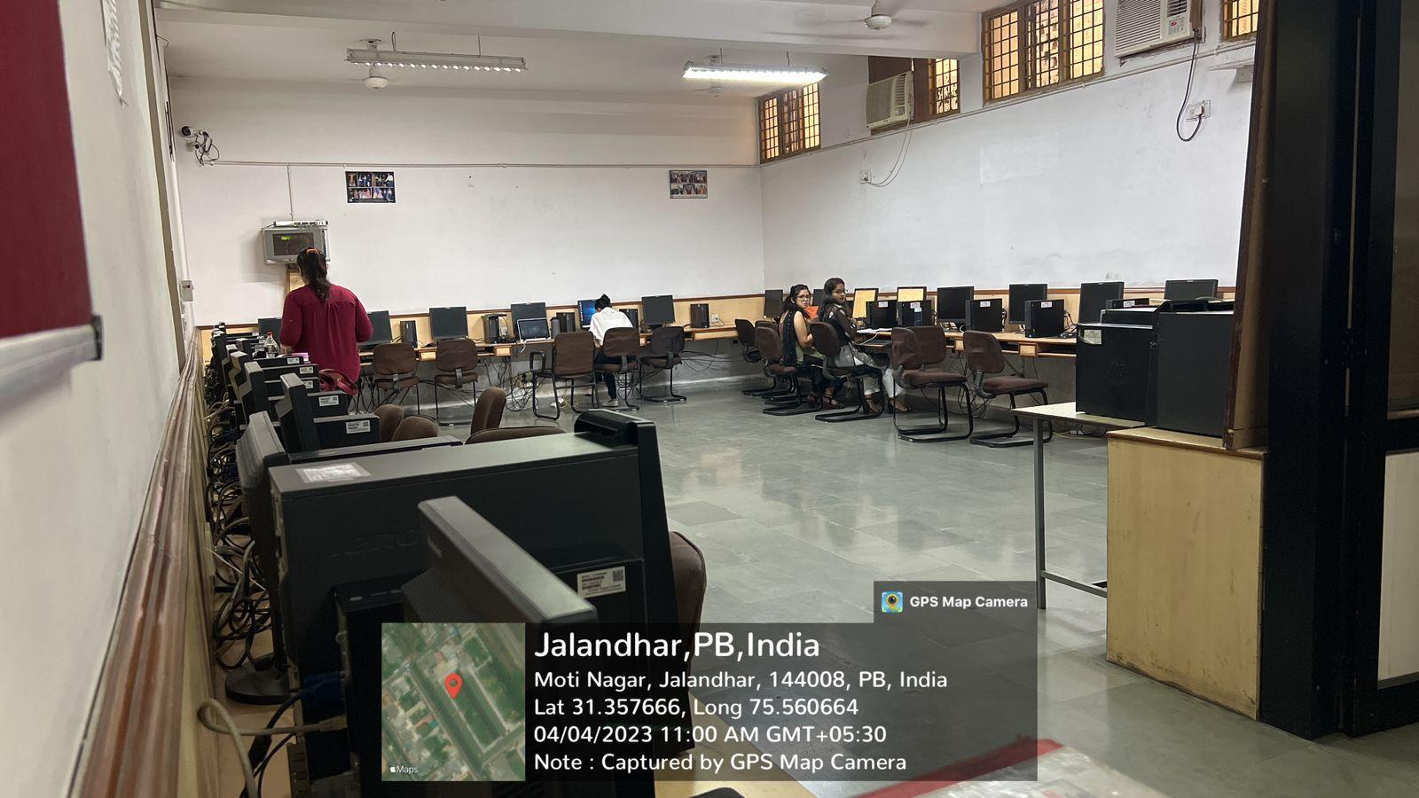

**COMPUTER LAB-1**

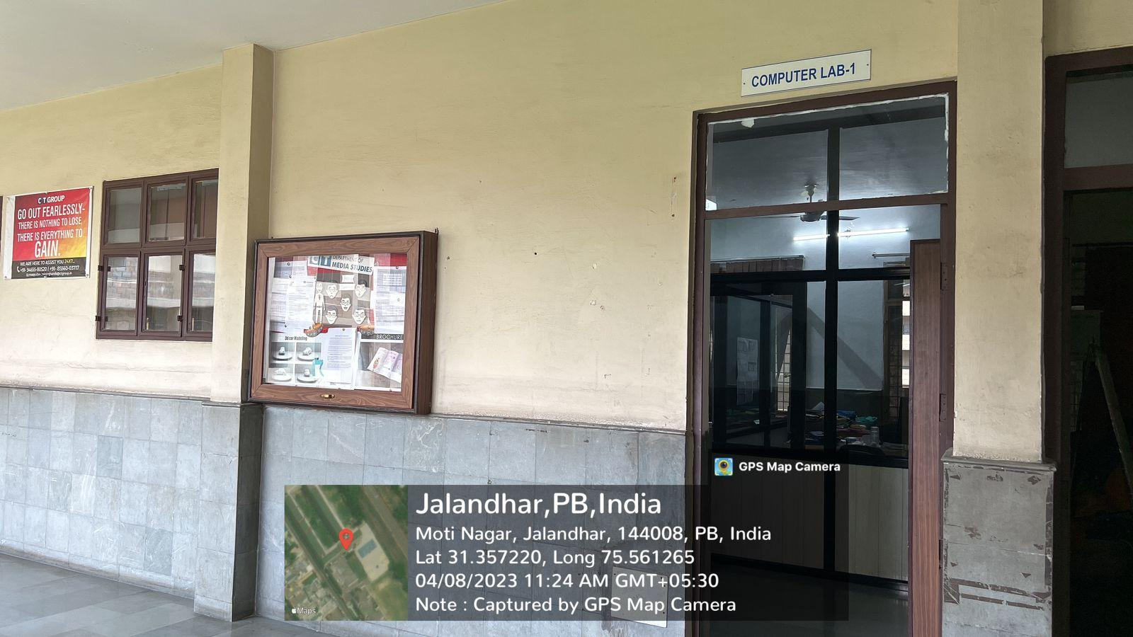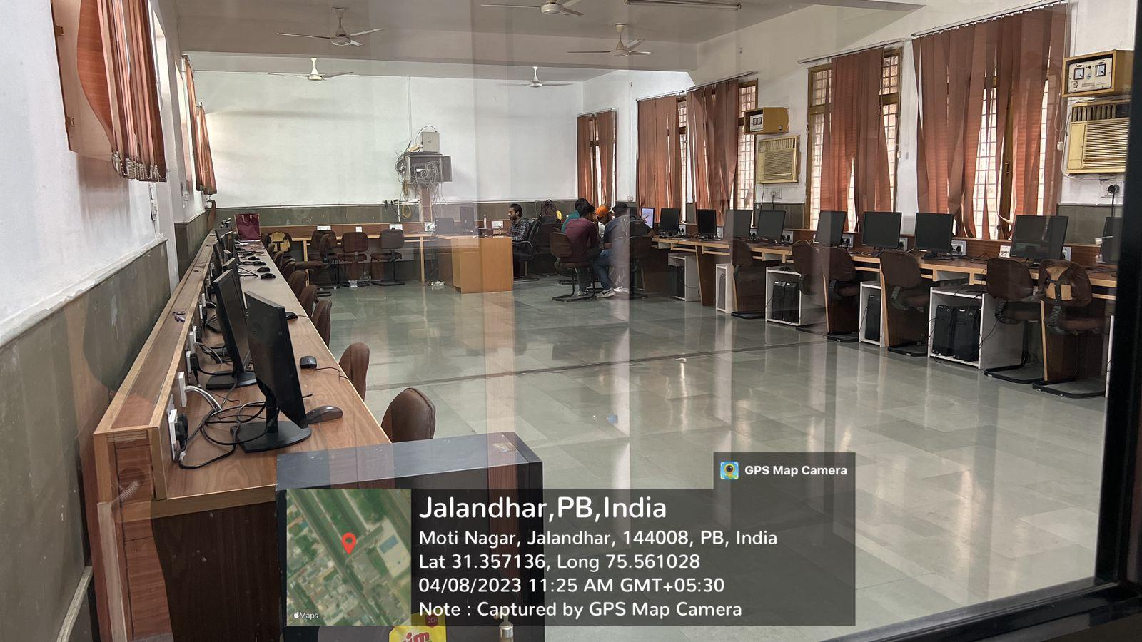

**SERVER ROOM**

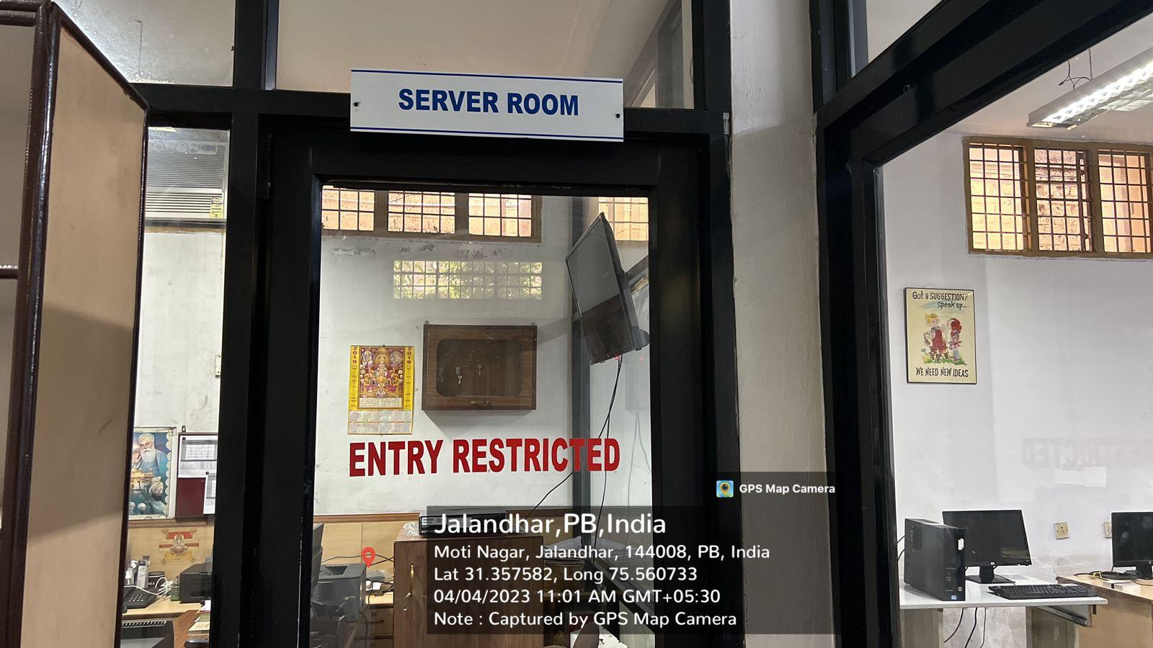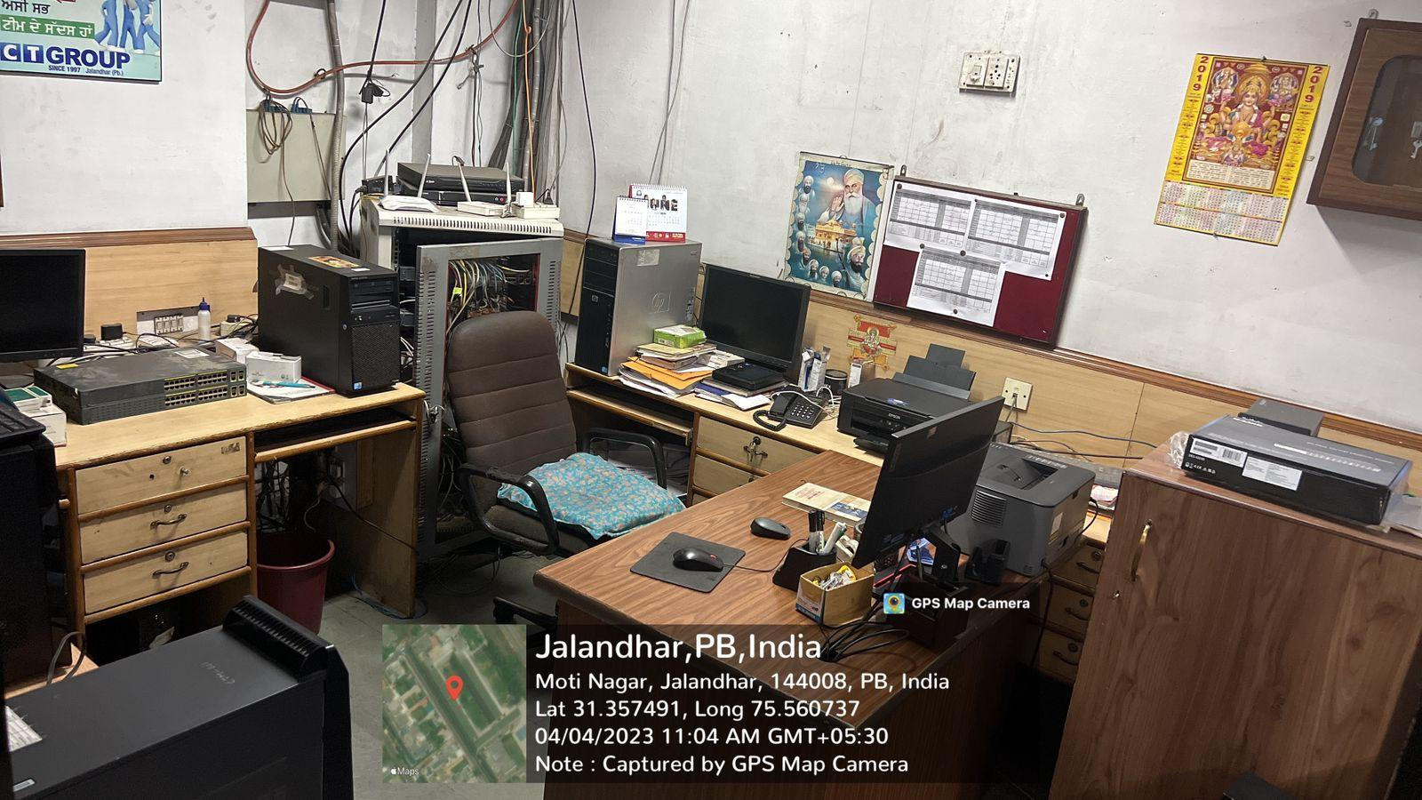

**VFX LAB**

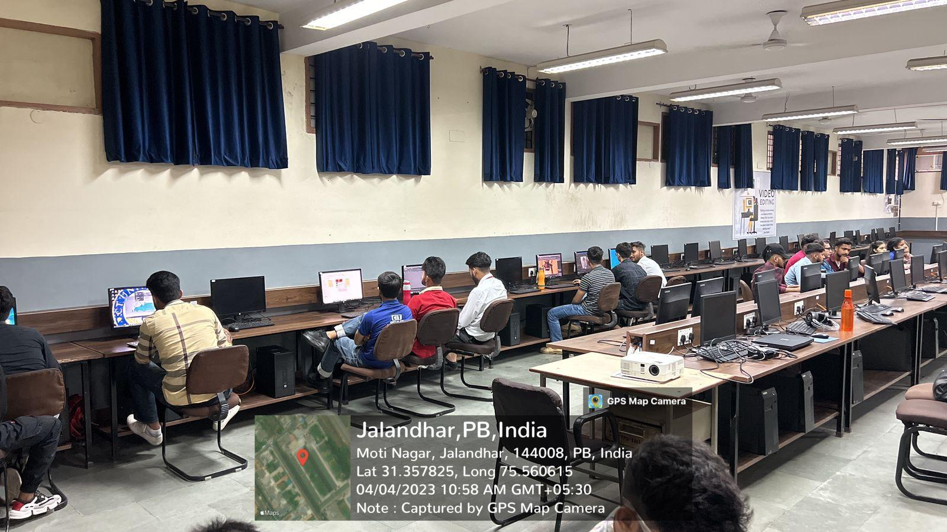

**LIBRARY**

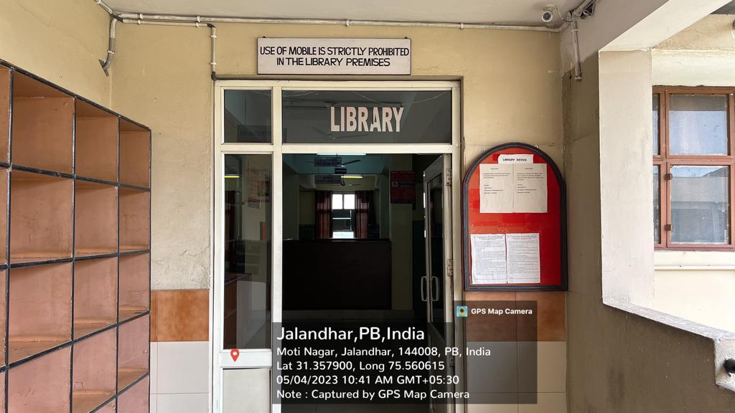

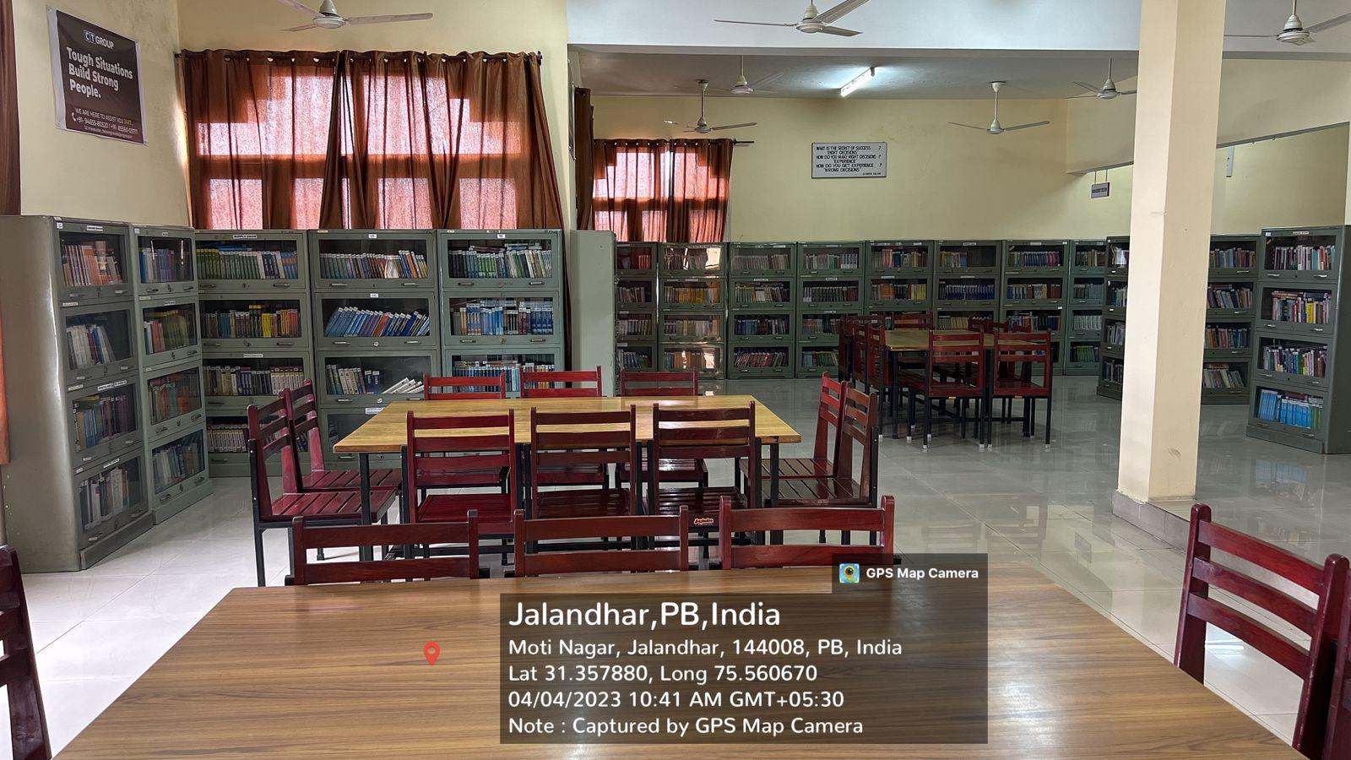

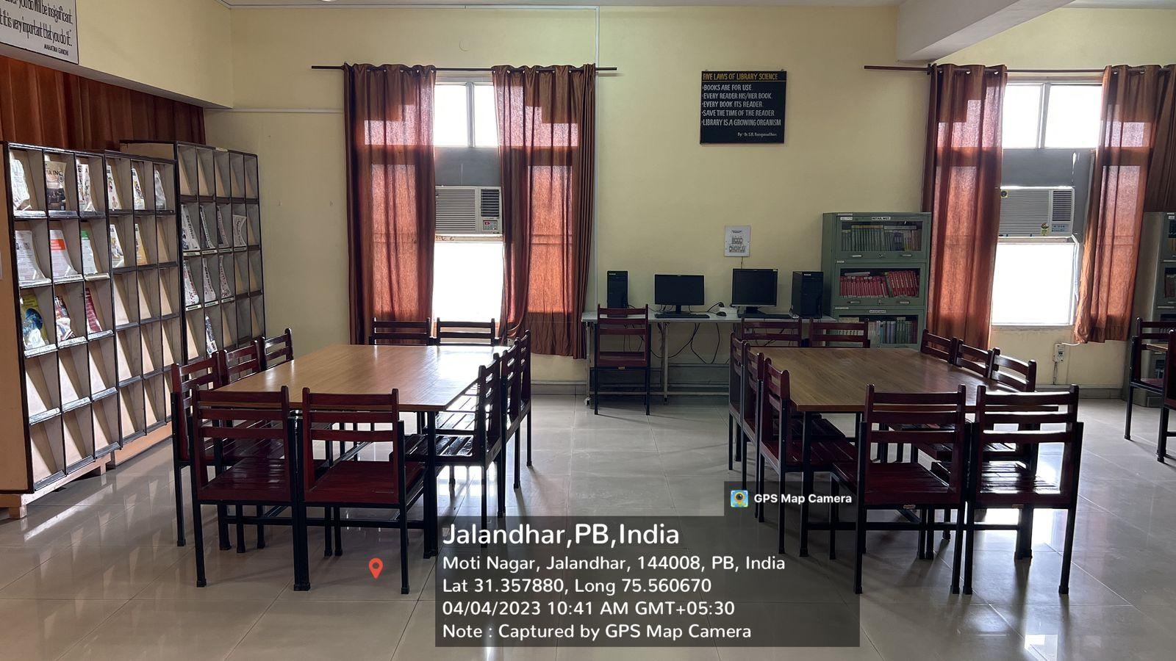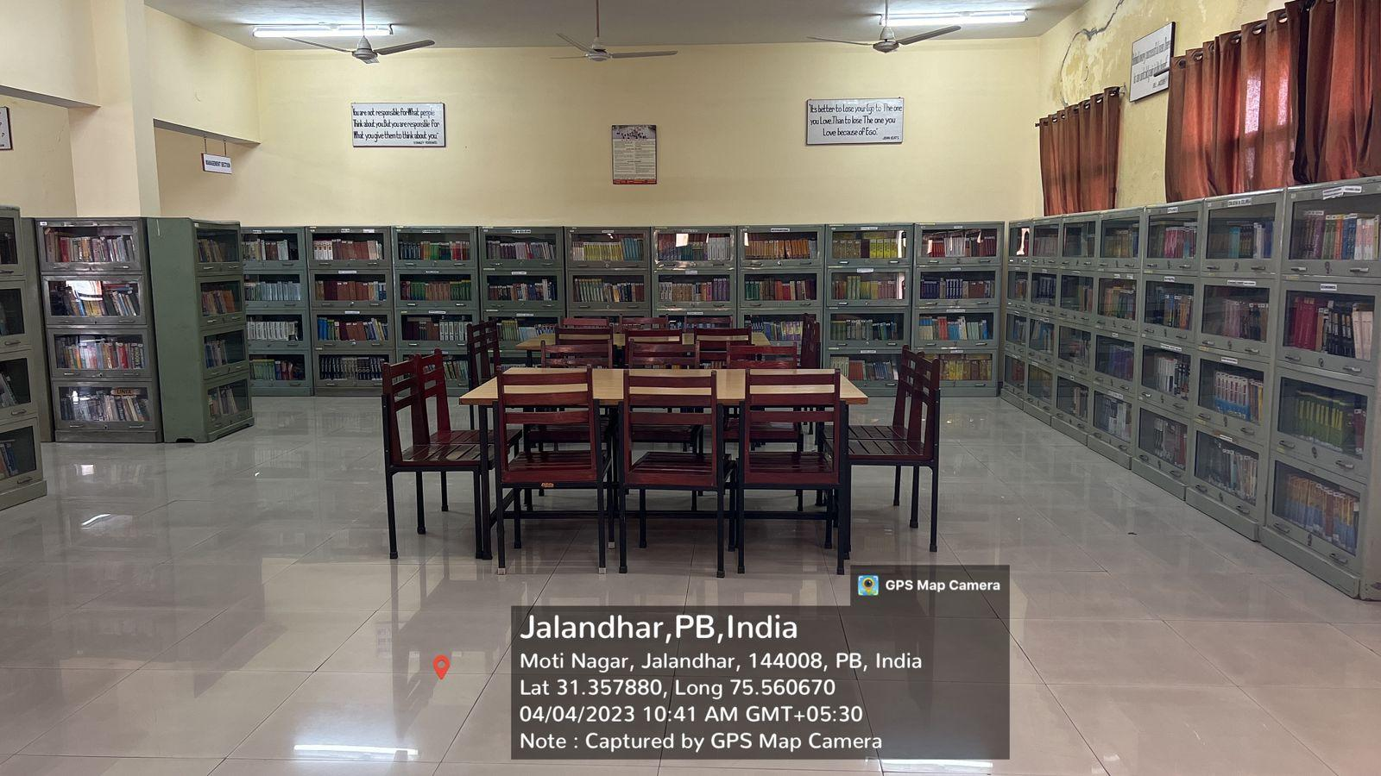

**BAR CODE READER**

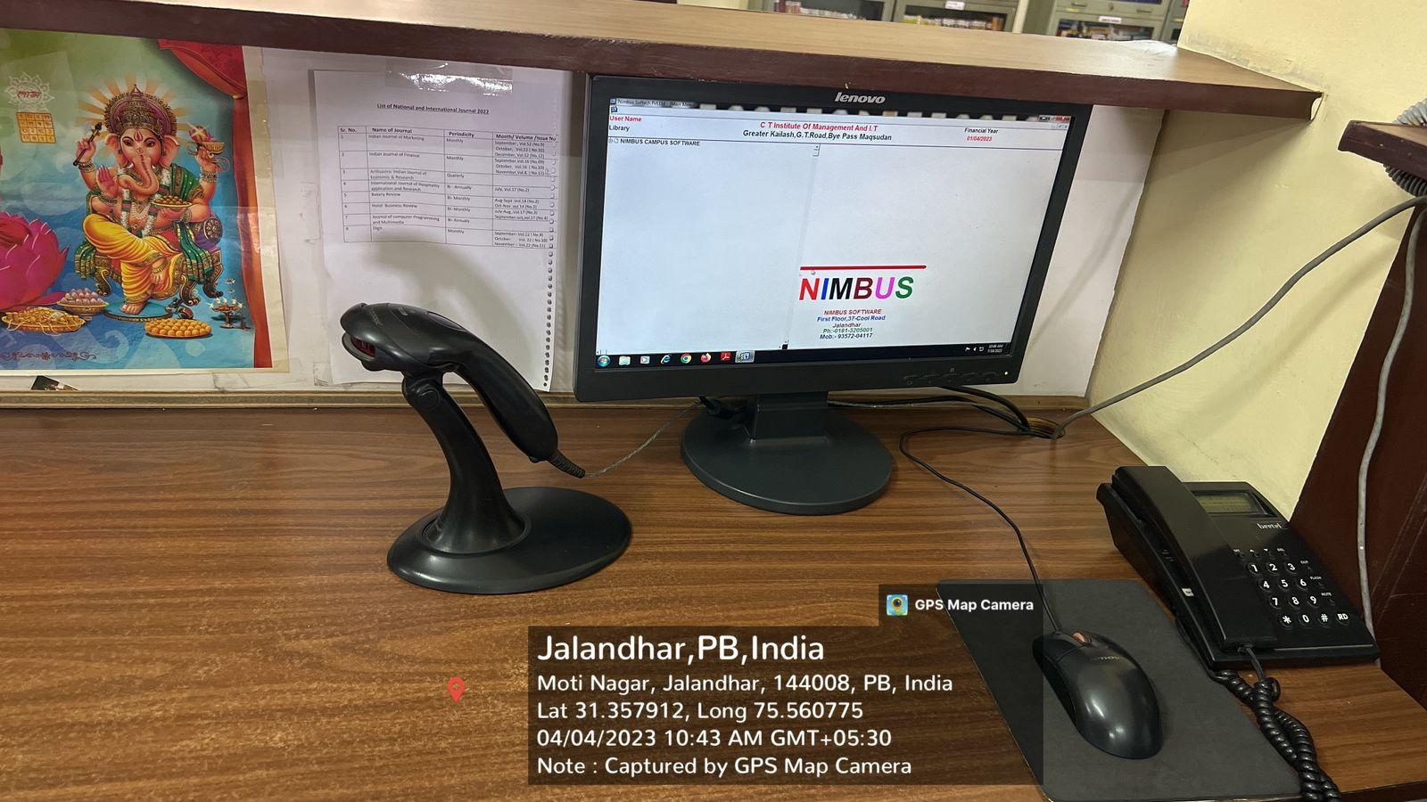

**BAR CODE SCANER**

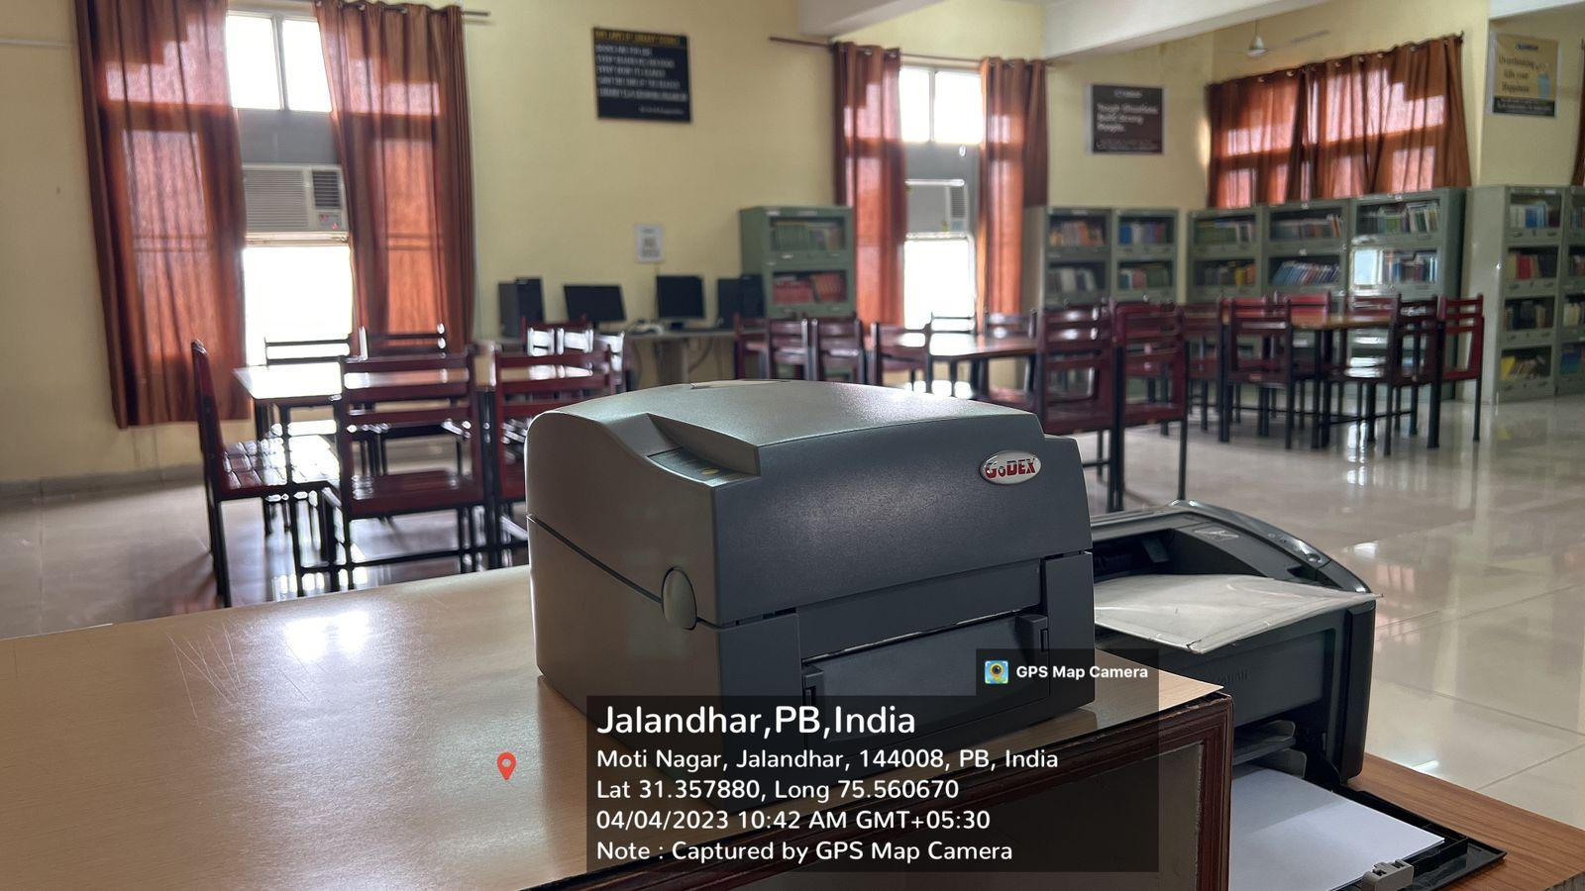

**COM RACK**

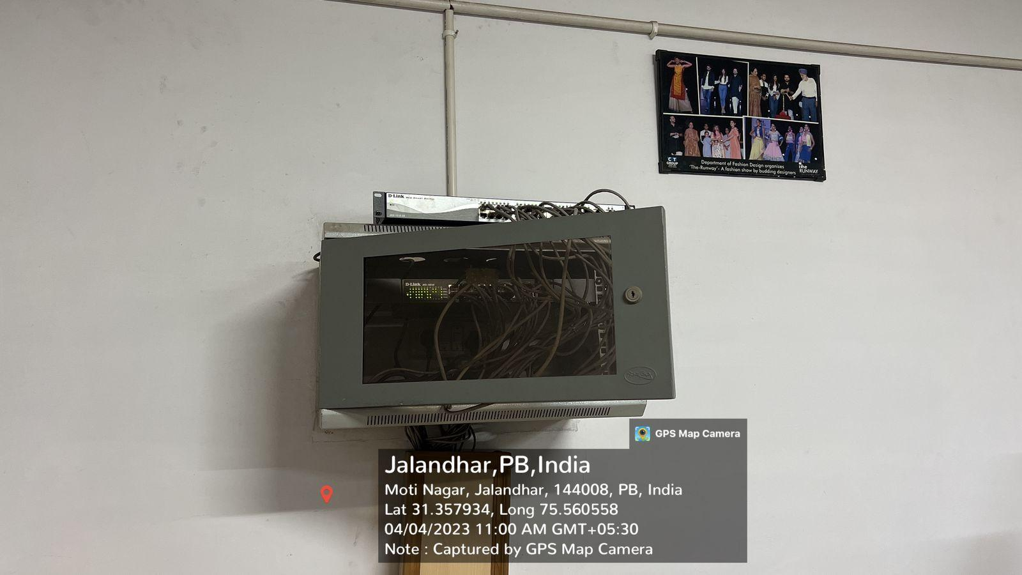

**CORIDOR WIFI FACILITY**

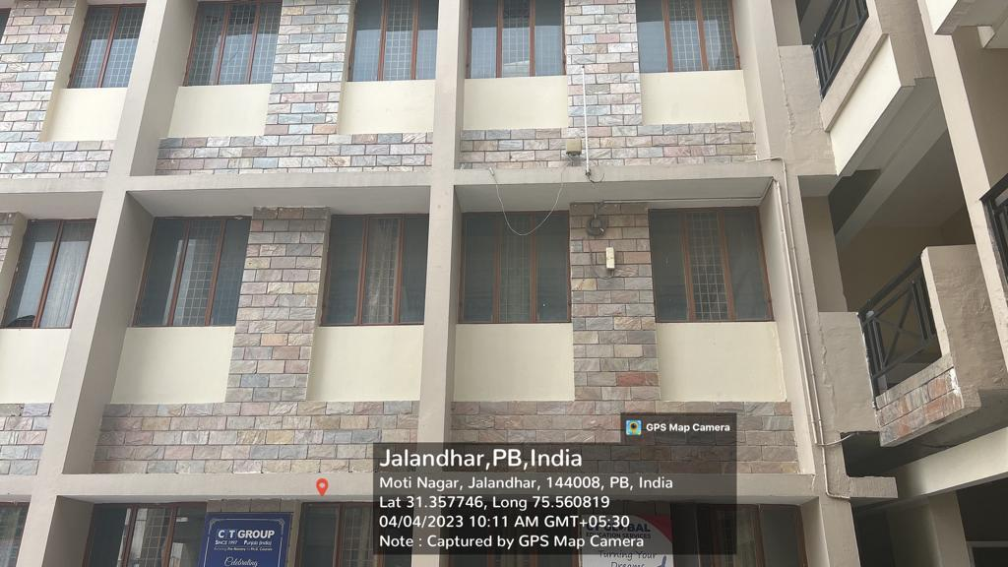

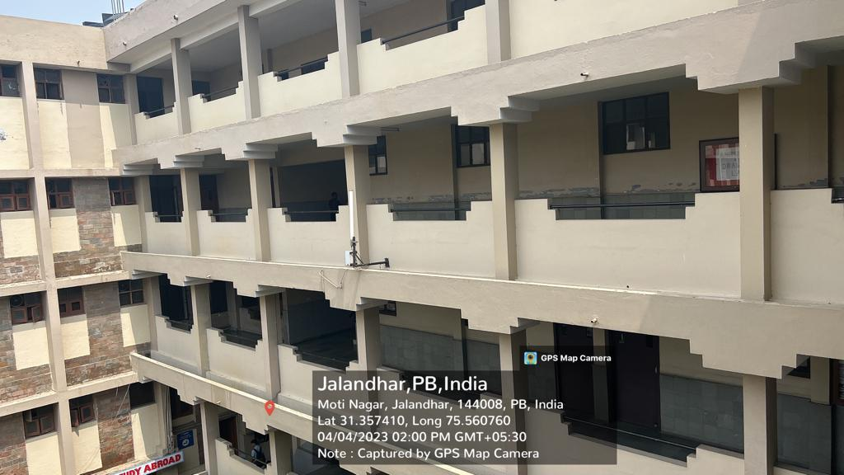

**LAUNDRY**

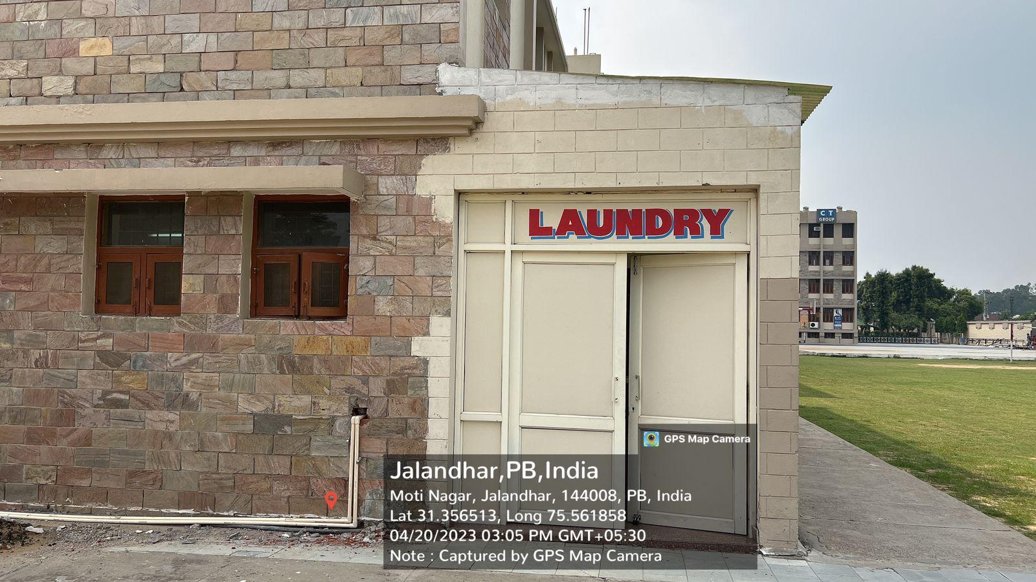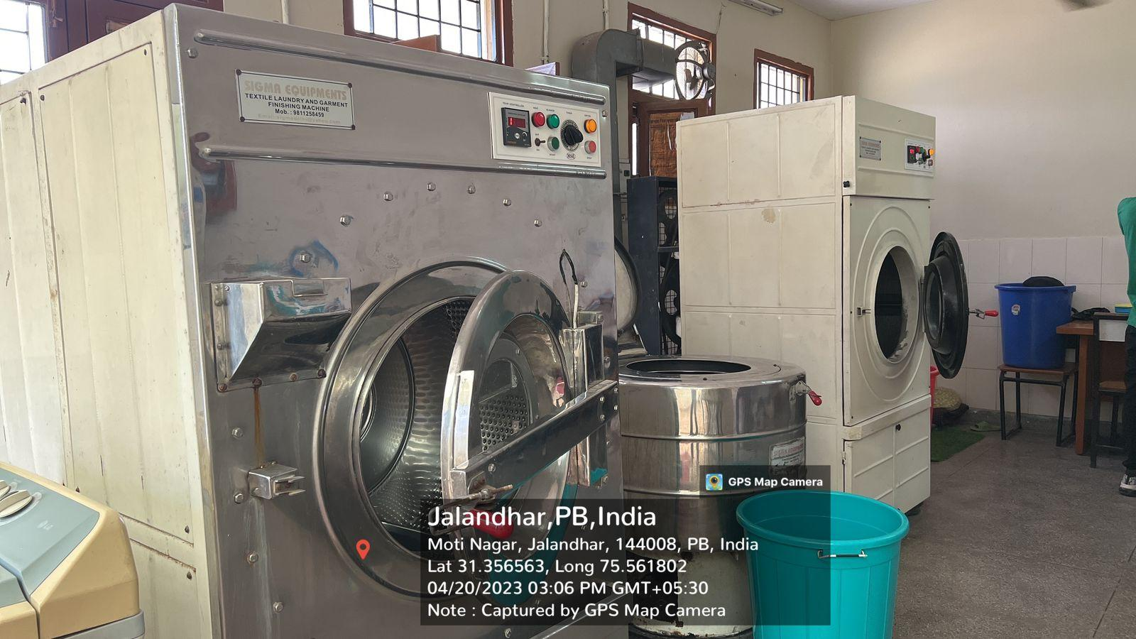

**STAGE FOR CULTURAL ACTIVITY**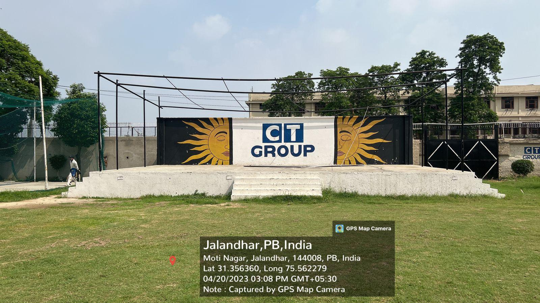

**SPORTS ACTIVITY**

**BASKETBALL PLAY GROUND**

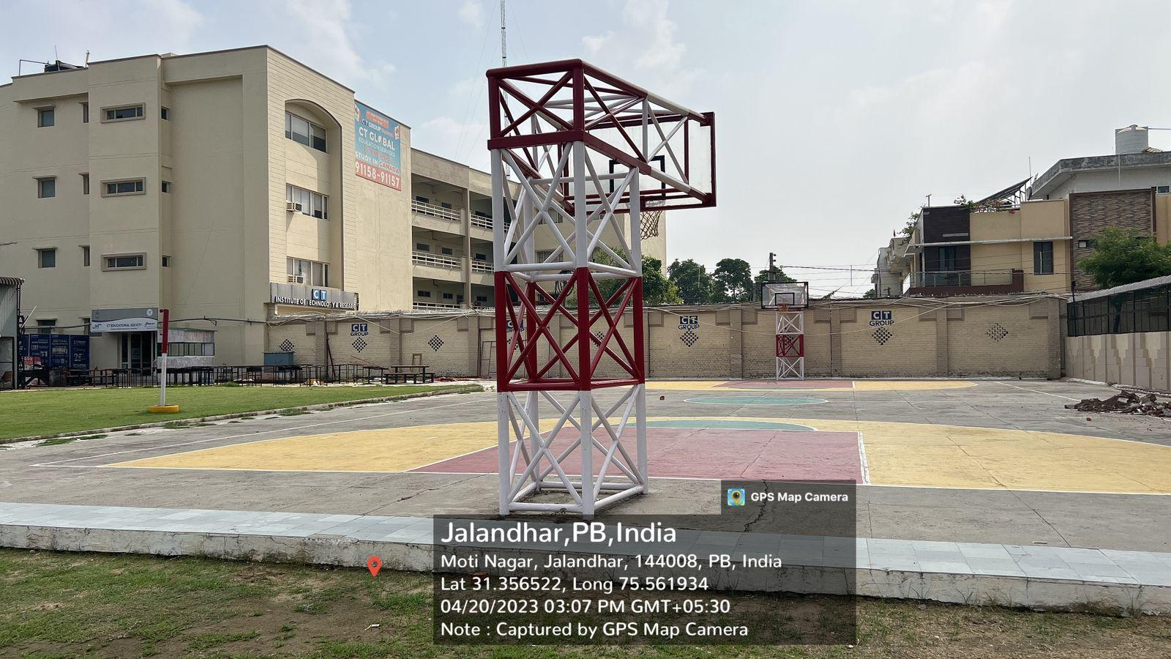

**PLAY GROUD FOR CRICKET, VOLLEY BALL, FOOTBALL**

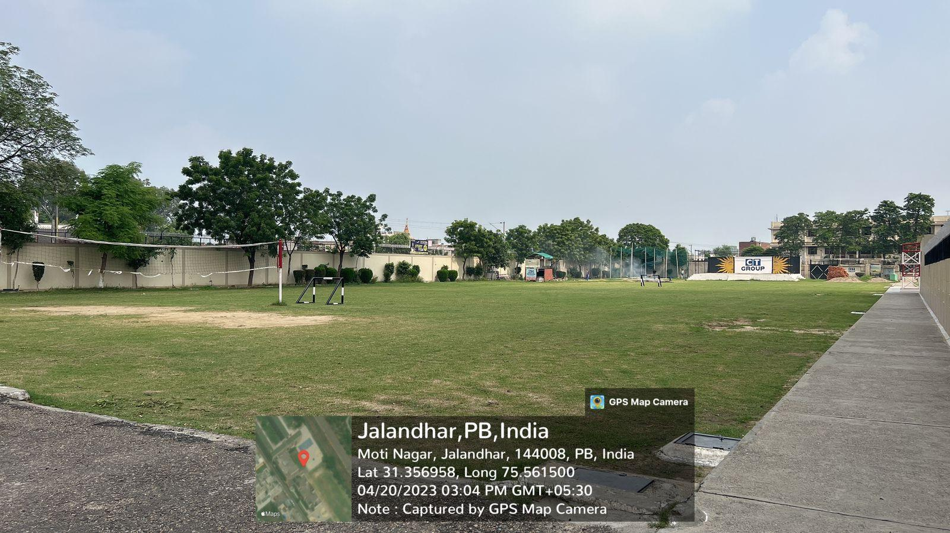

**FITNESS CENTRE**

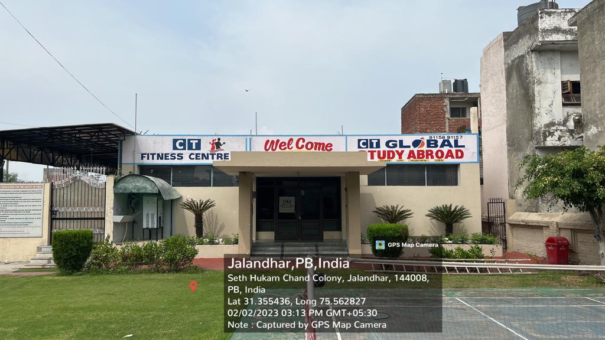

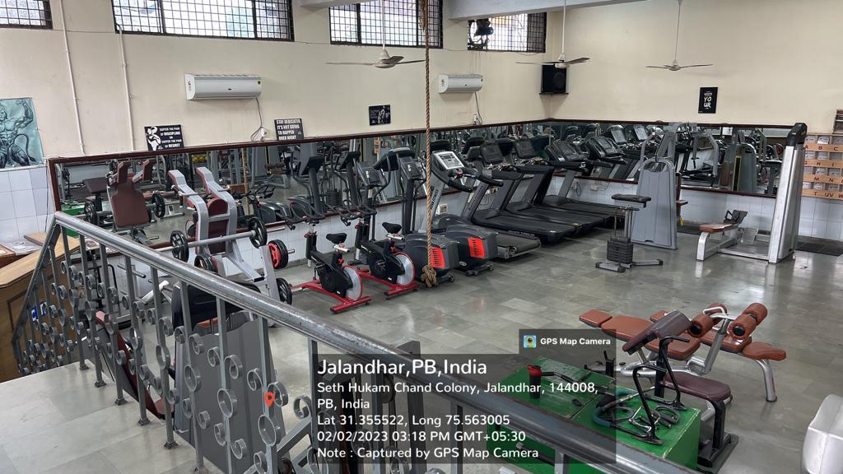

**SWIMMING ACADEMY**

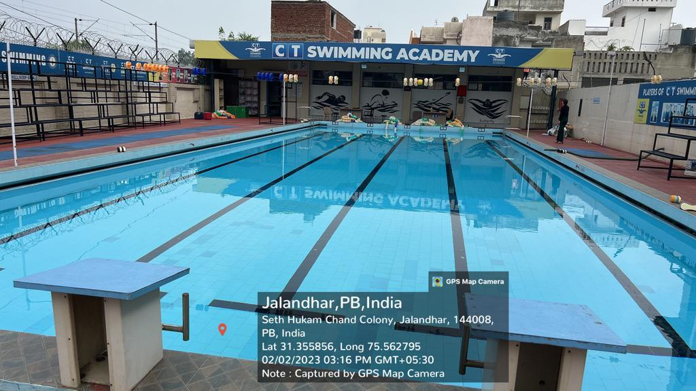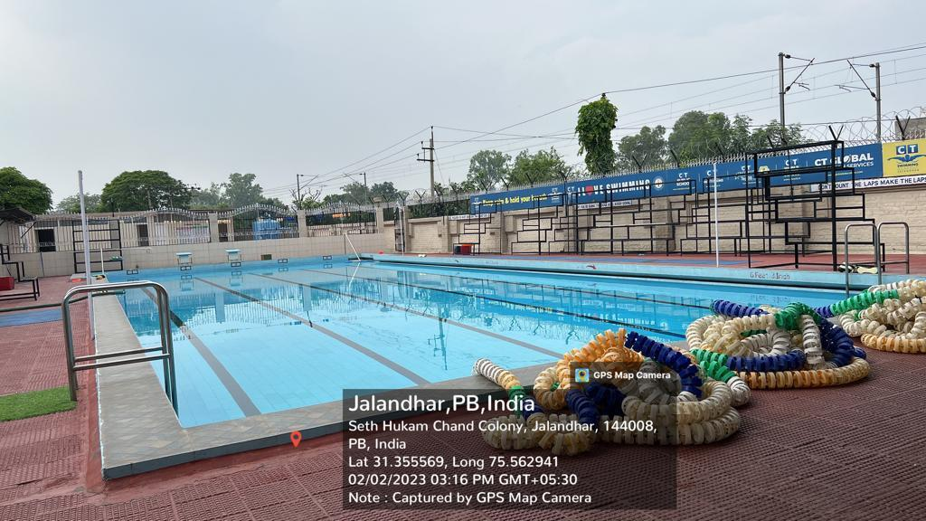

**BADMINTON COURD**

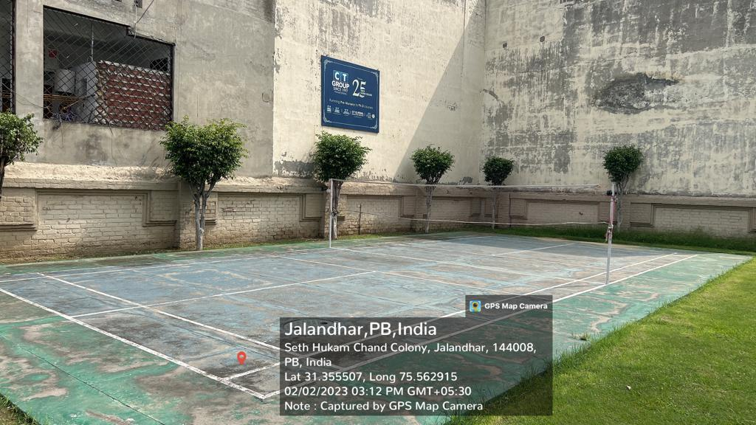

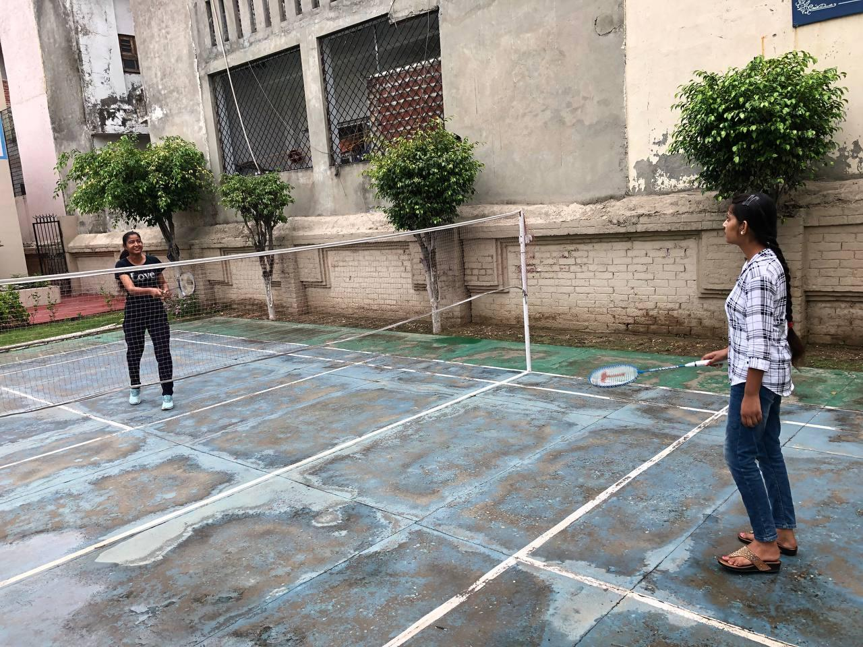

**CHESS**

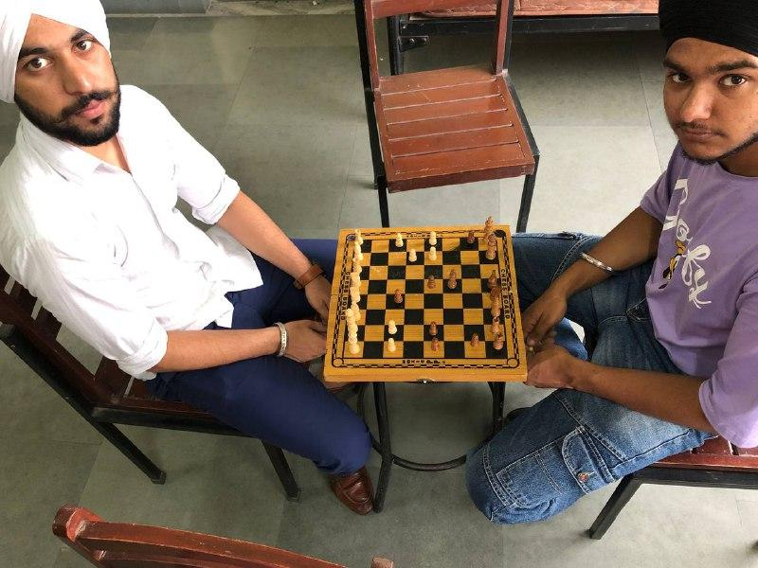

**SHOT PUT**

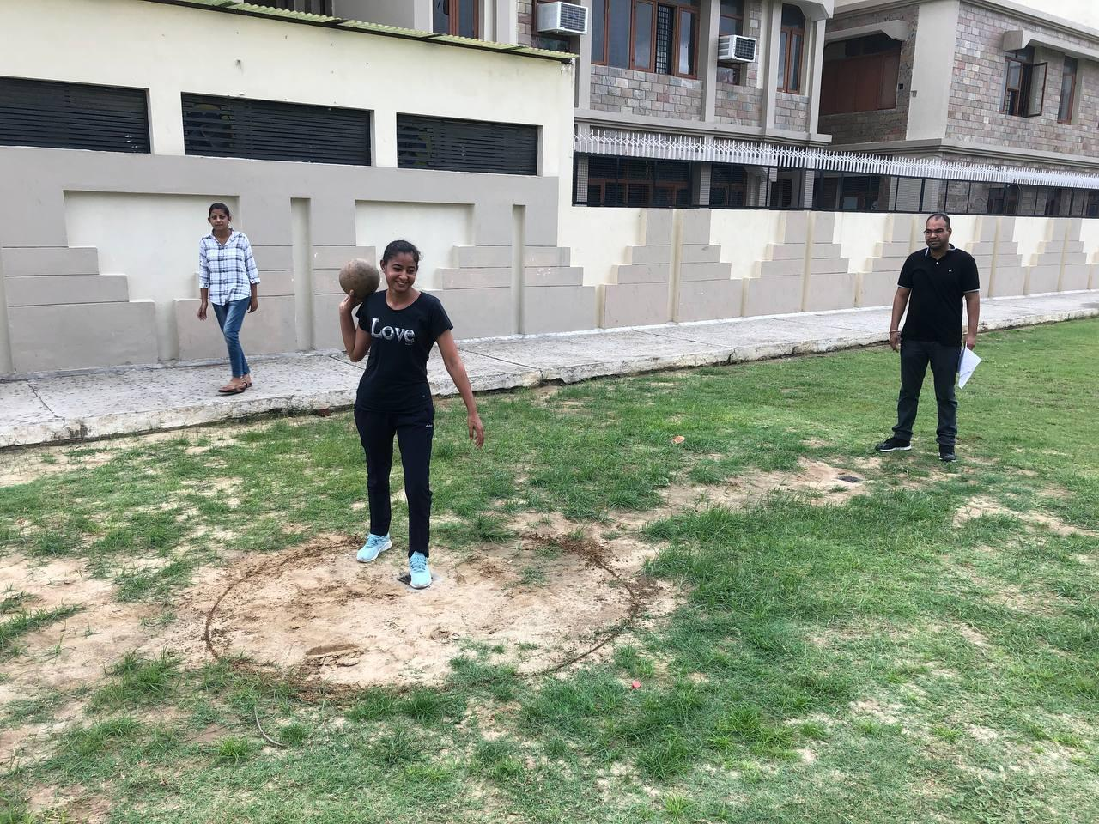

**LUDO**

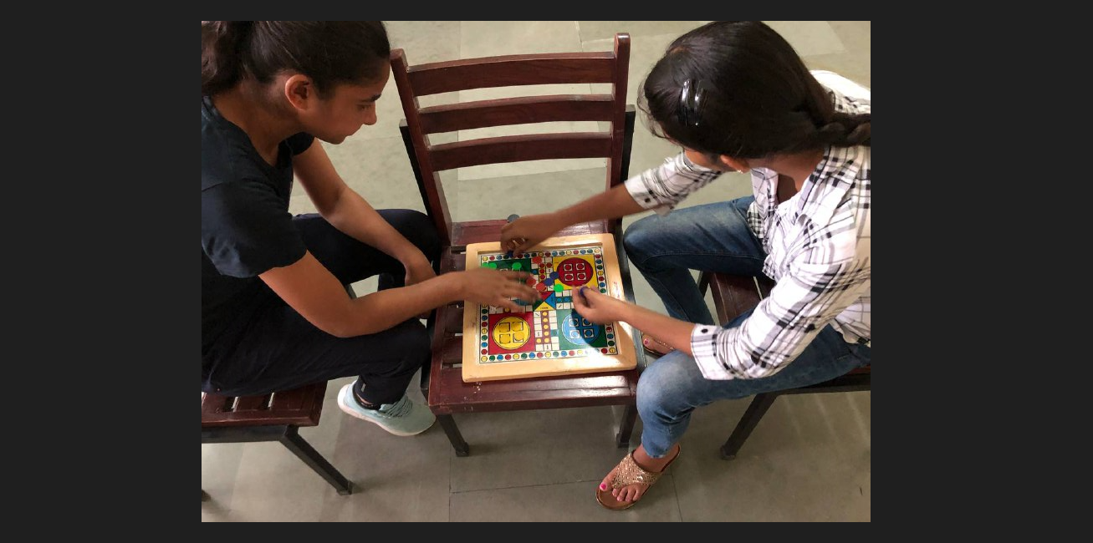

**CT MARATHON**

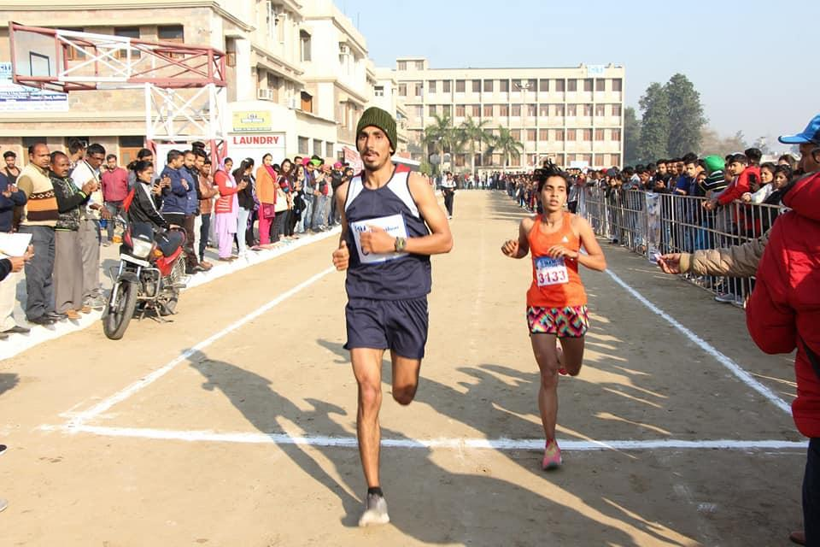

**BOYS HOSTEL**

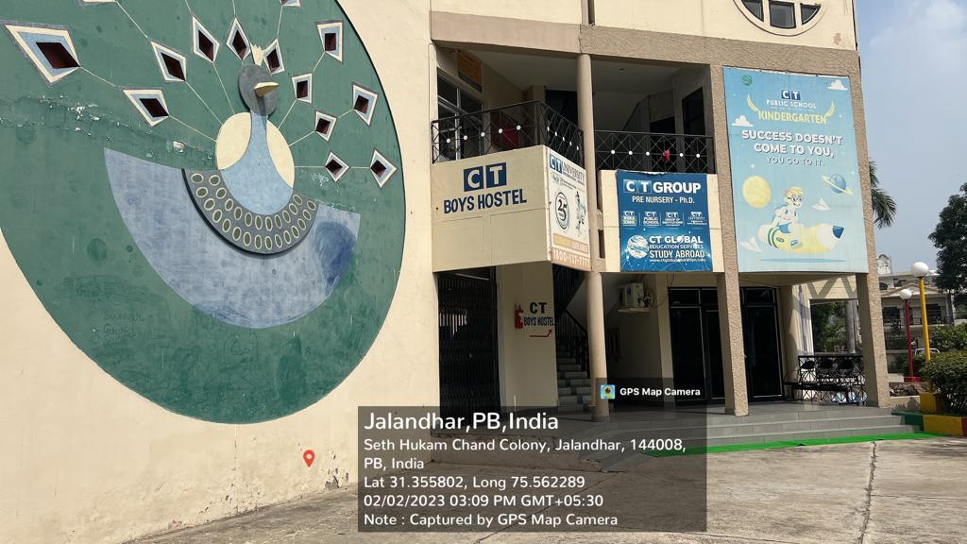

**AGRICULTURE FIELD AREA**

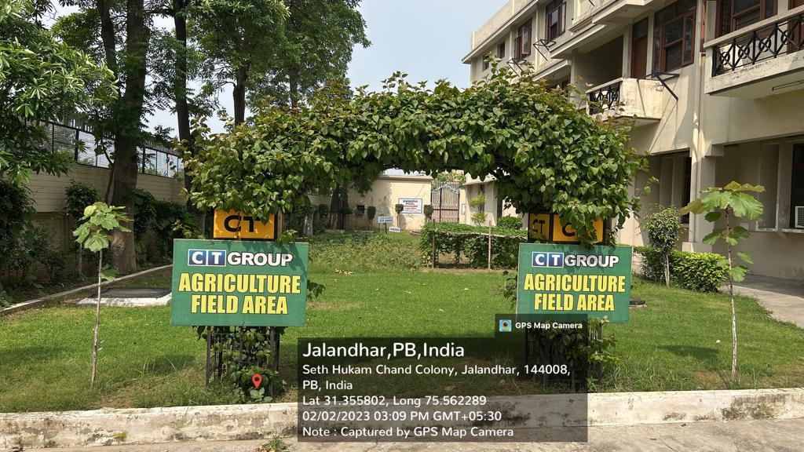

**Bio-Metric Machines** 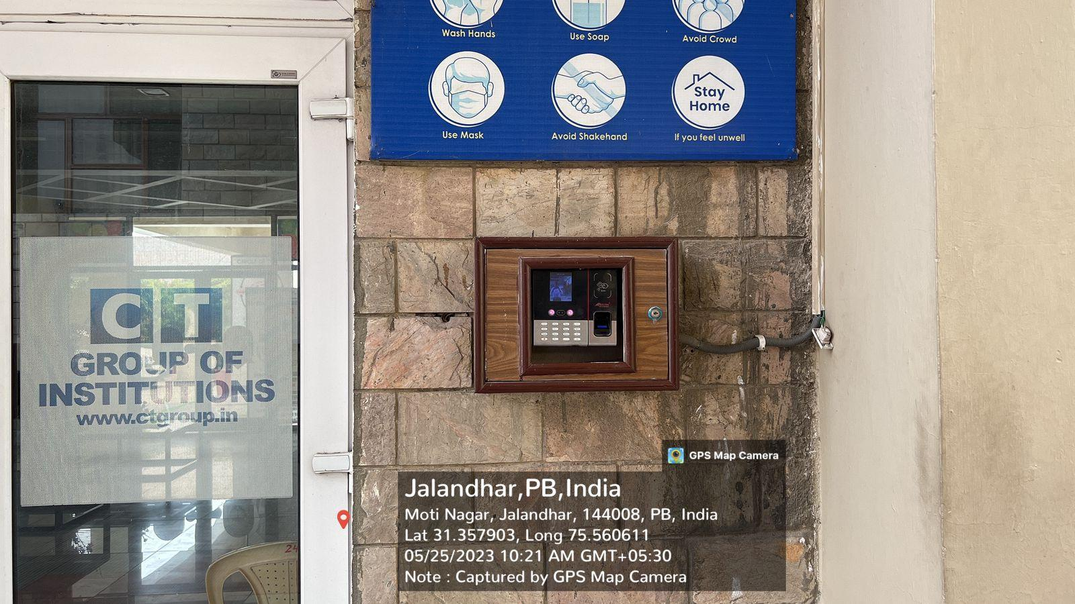

**POWER GENERATOR**

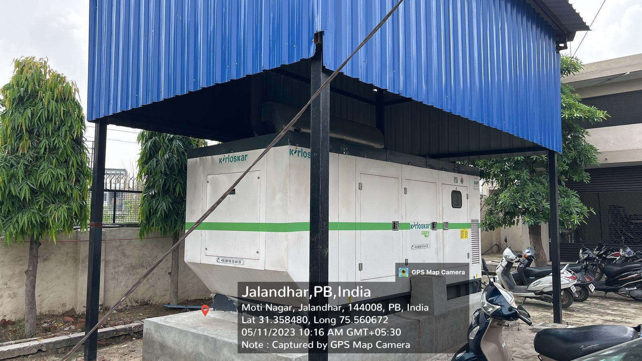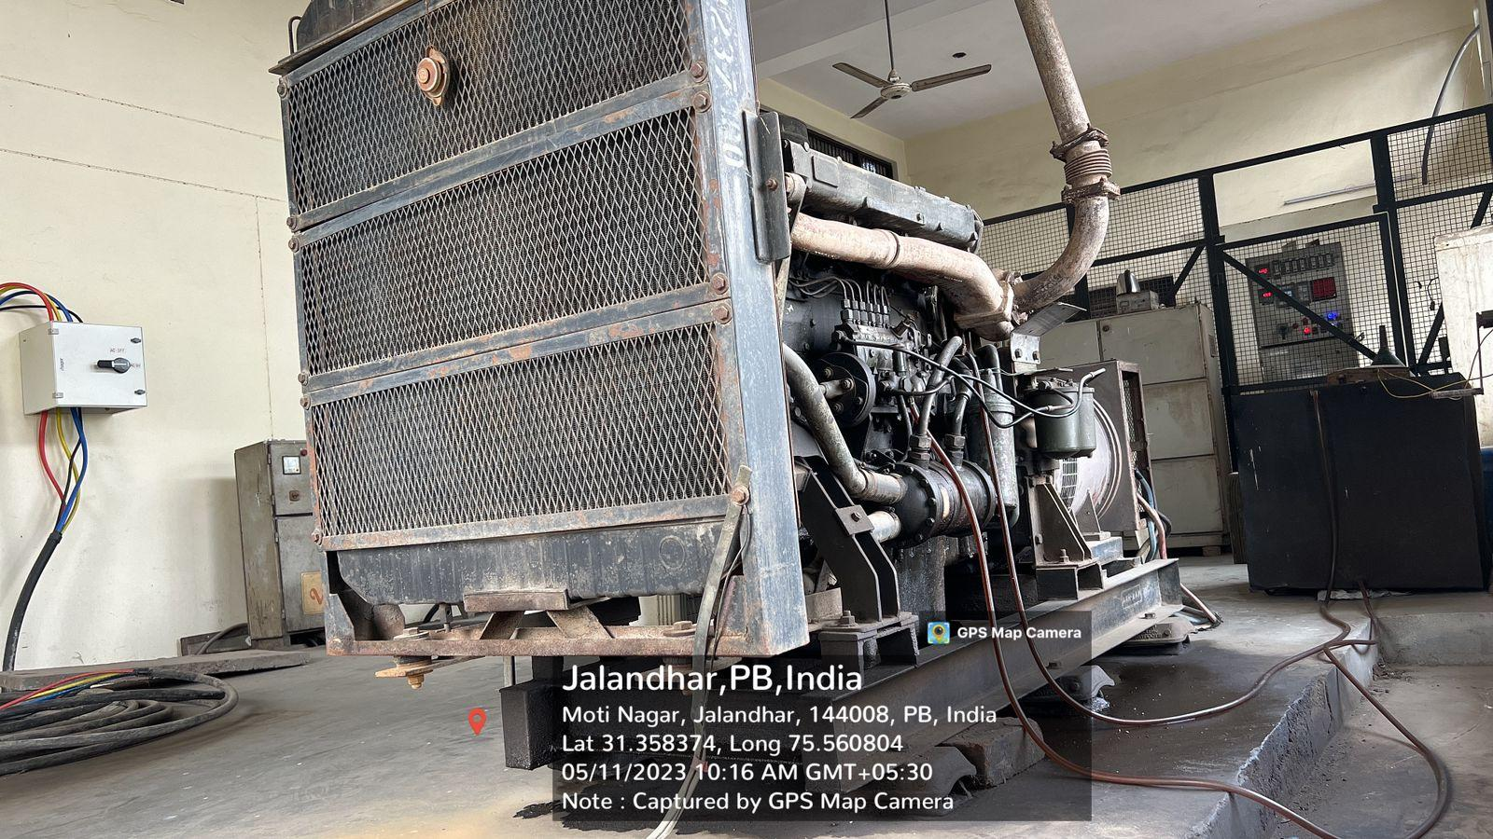

**SECURITY CHECK POST**

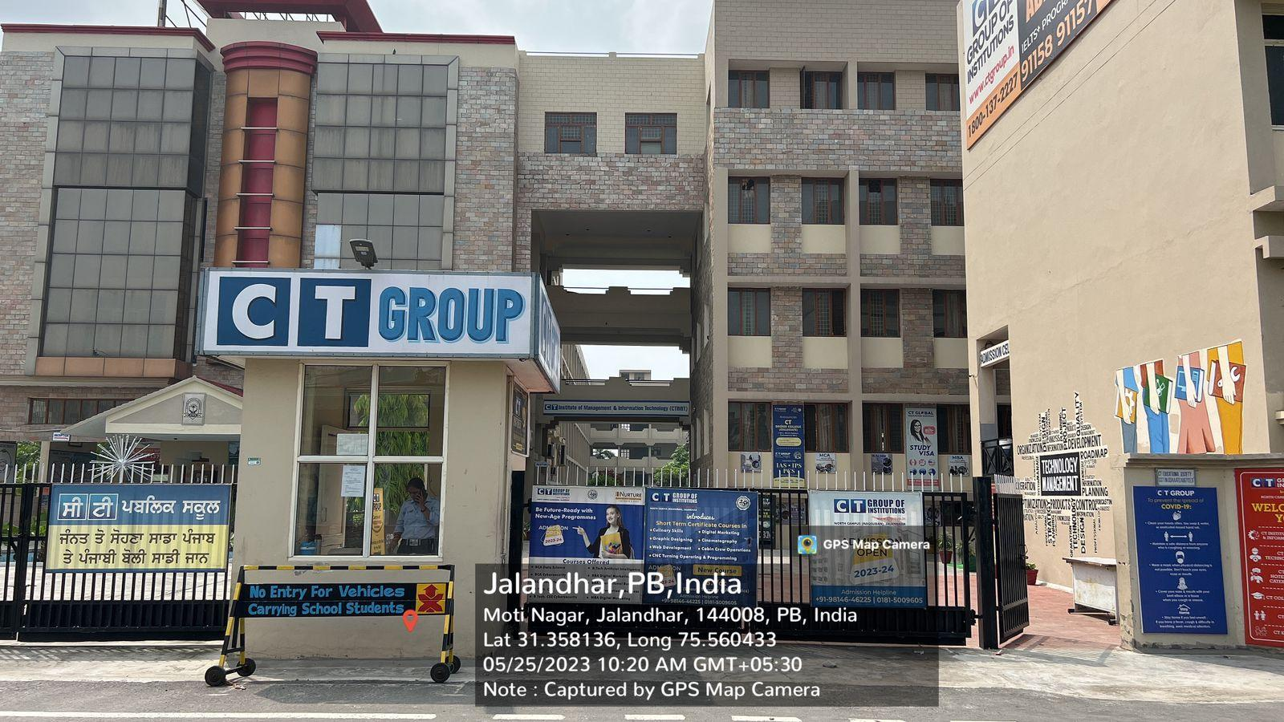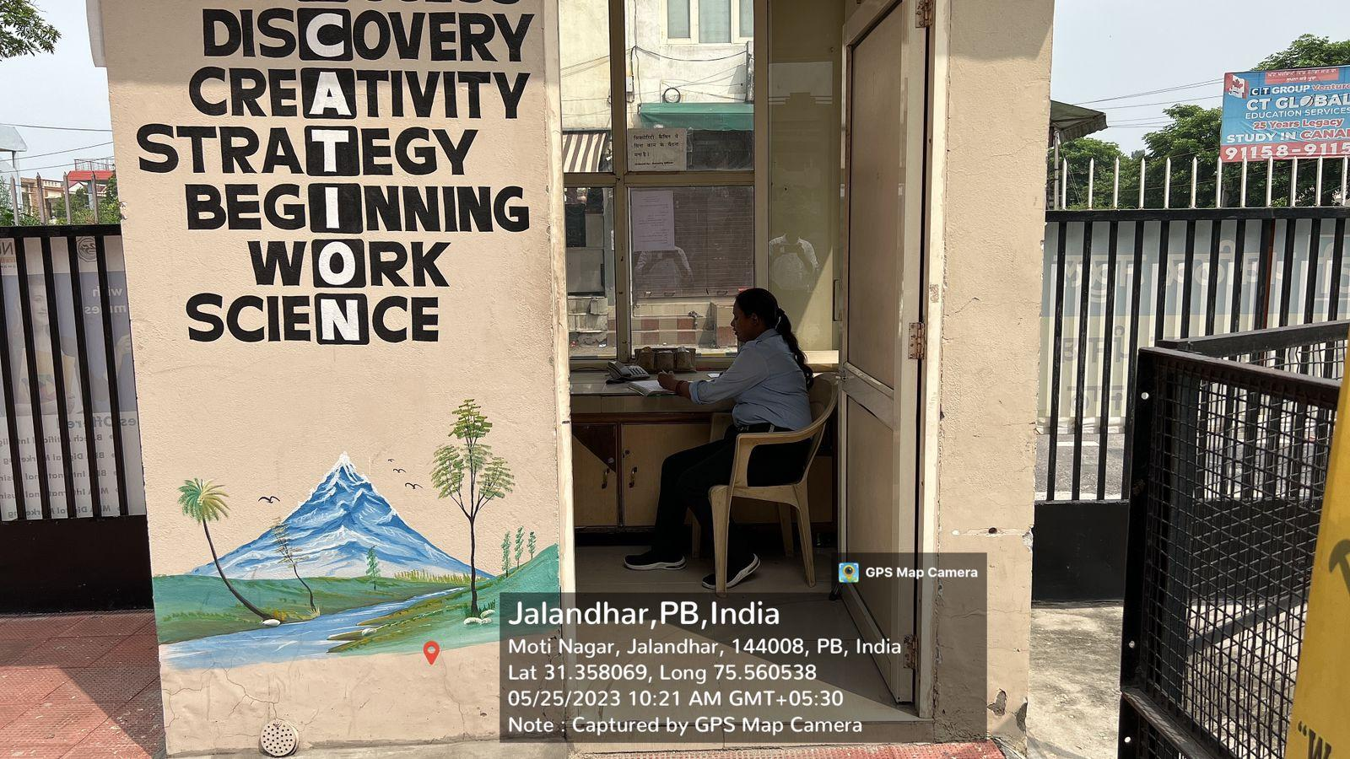

**CT BUSSES SERVICE**

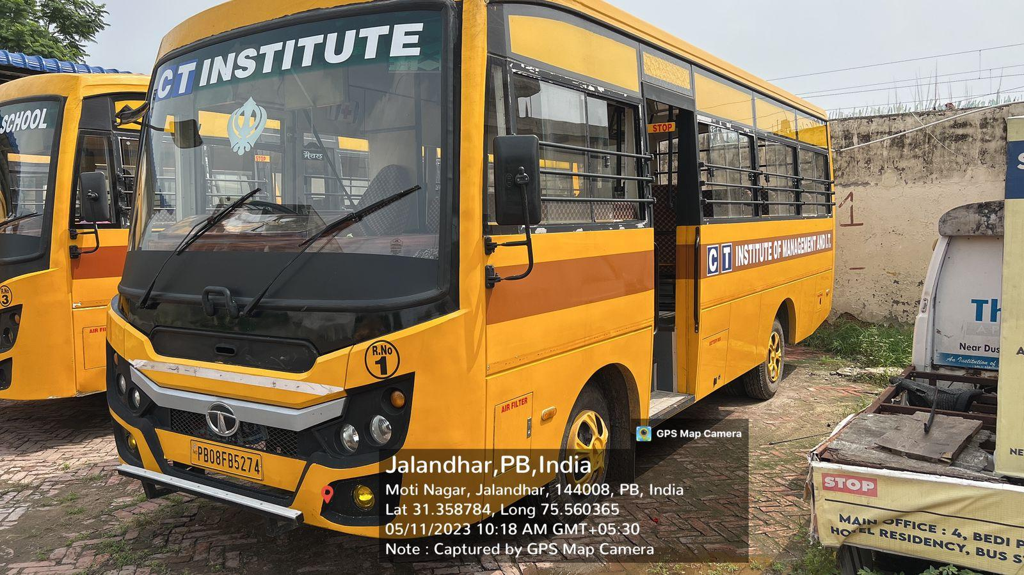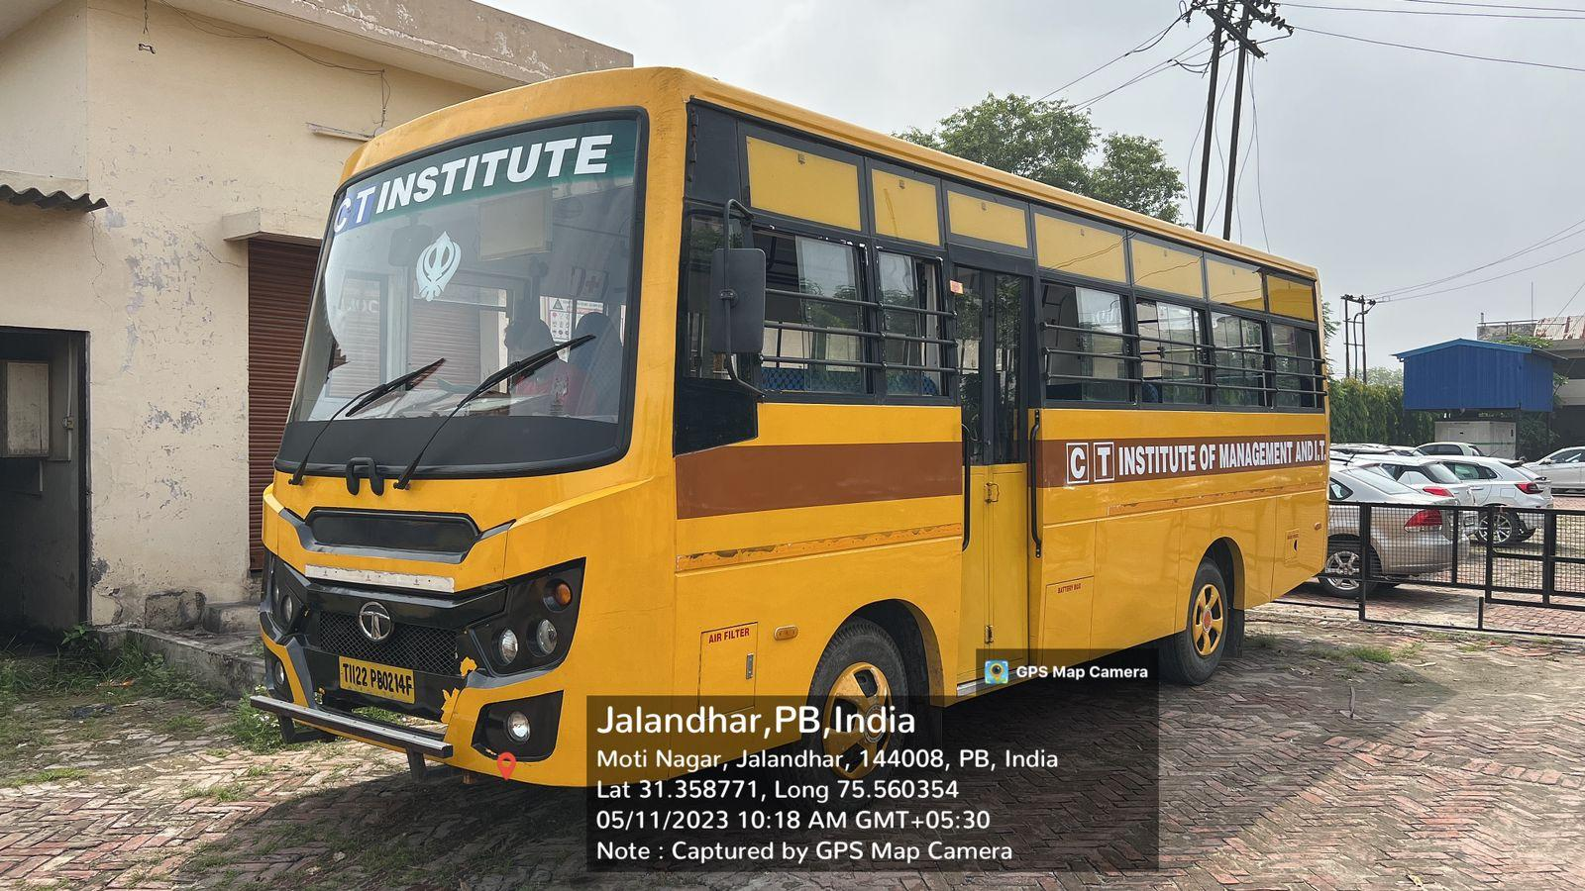

**TUCC SHOP**

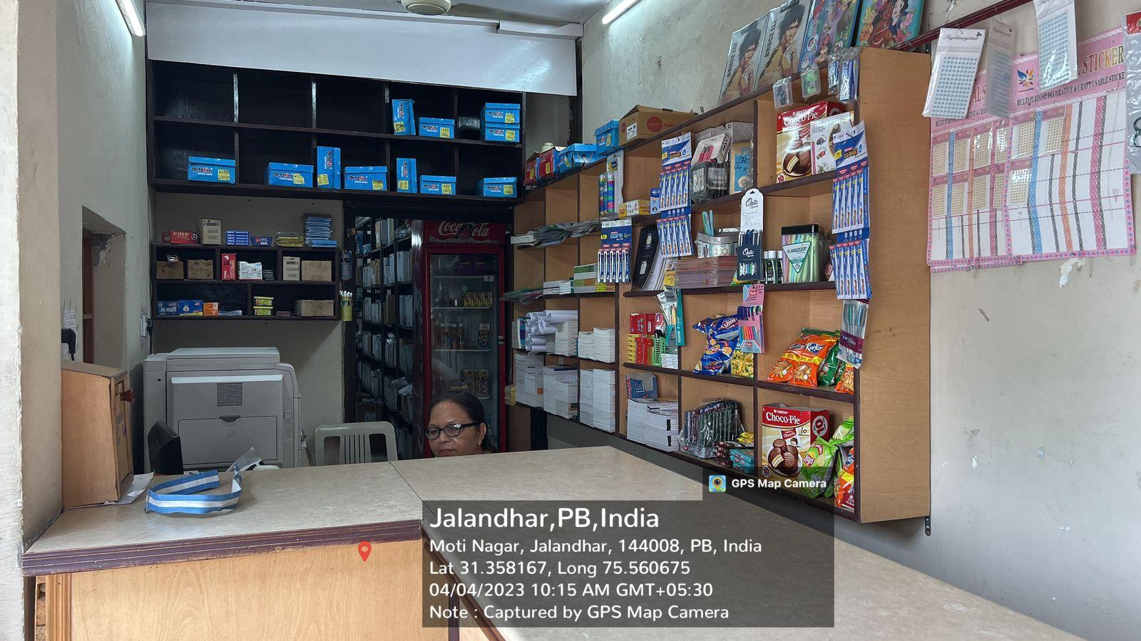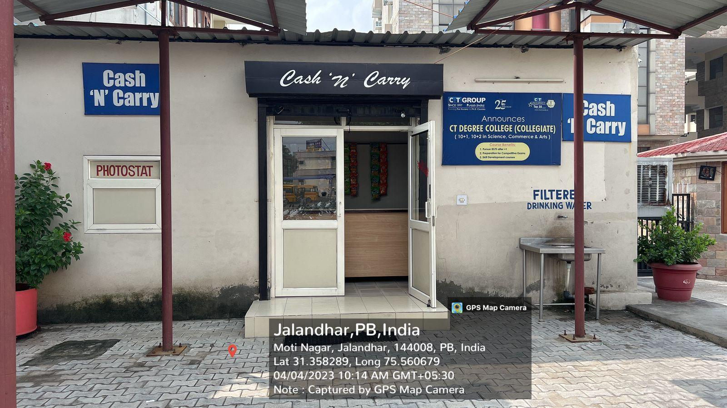

**ADMISSION CELL**

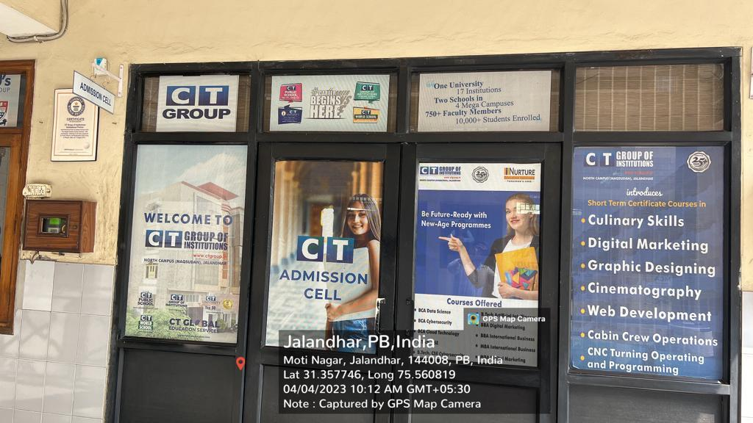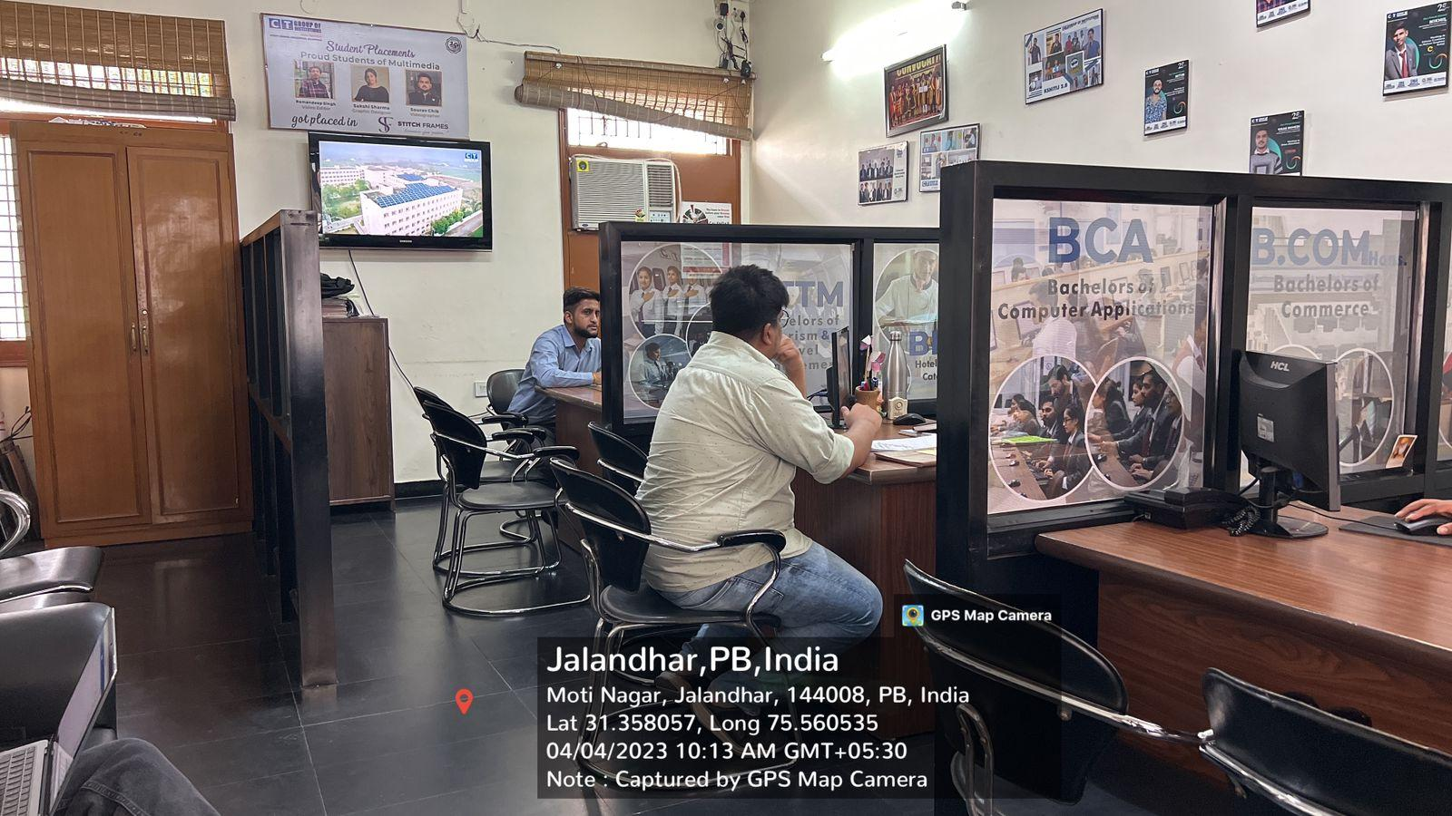

**CAFETERIA**

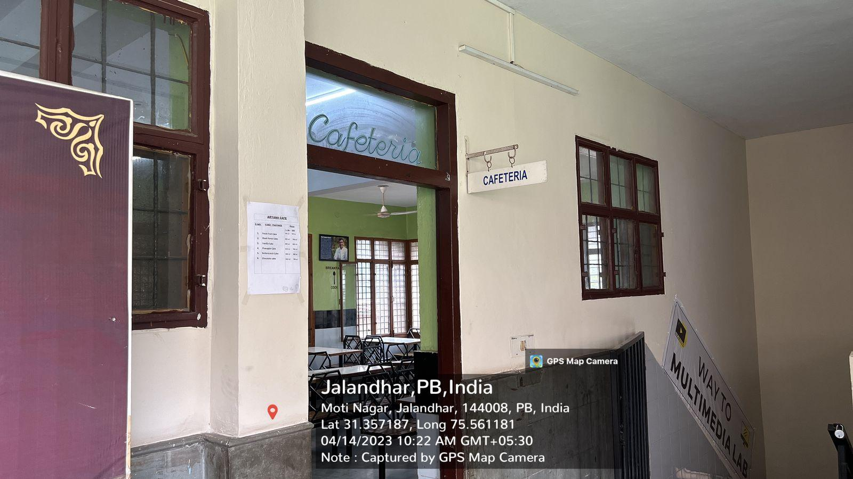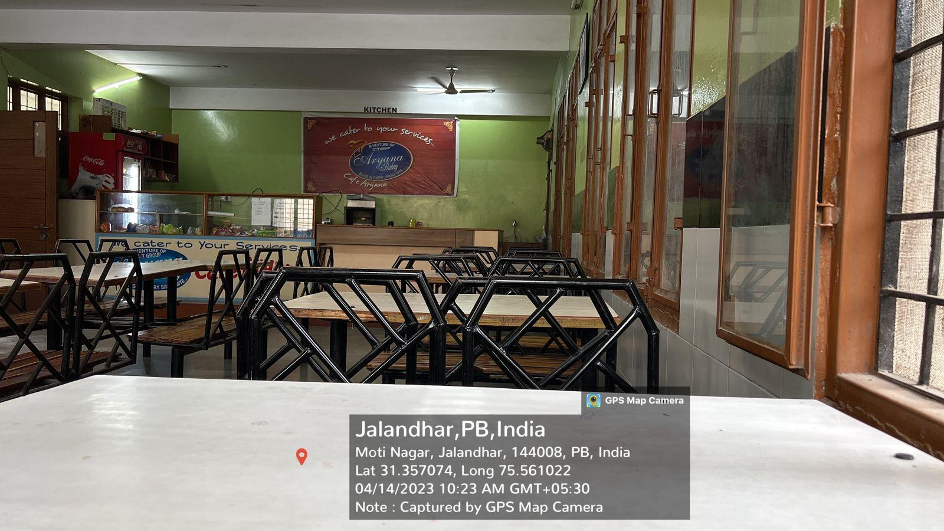

**MESS FACILTIES**

